Candidate Number: 1018 Candidate Name: Nischal Gurung Centre Number: 13116

ocr a level project
Mathematical Quizzing Website

Contents
Analysis of the problem 2
Introduction 3
The Problems 4
1. Generation of questions 4
2. Difficulty of questions 4
3. Keeping track of user progress 4
4. Non-computational problems 4
Researching the problem 5
1. My solution to the problem 5
2. Existing solutions 5
3. Key features of the solution 6
4. Limitations of the solution 8
5. Specify the proposed solution 8
6. Success criteria 11
Design of the solution 11
Functional Decomposition 11
Algorithms 12
Validating username for register page 12
Validating password for register page 13
Validating email for register page: 14
Functions needed for log in page: 14
Differentiation function for calculus questions: 15
Integration function for calculus questions: 16
Logarithms function for calculus questions: 17
Exponential functions for calculus questions 17
Function to check user input when playing: 18
Flowcharts 20
Register page 20
Login page 21
Calculus Questions for Hard difficulty Page 22
Register page initial design 23
Login page initial design 23
Calculus Questions for Hard Difficulty initial design 24
Development of the solution 24
During development 24
Development and Testing logs 25
Evaluation of the solution 58
Beta testing 58
Client testing 61
Client feedback 61
Conclusion 63
Success of the solution 64
Maintenance and Development 65
Complete code for my solution 66

Analysis of the problem

Introduction
The client is my cousin who has just finished his GCSES and is planning to do A-level maths. He is afraid that over the summer holidays, his maths skills might deteriorate and may be at a large disadvantage when starting Year 12 maths. Although there exist several websites online that can quiz his maths skills, he feels that it does not broadly measure his maths skills. Based on this, I have decided to propose a solution to help him.

The issue I have chosen is some basic maths which includes addition, division, etc. Along with basic algebraic maths and a part of AS pure maths which includes definite integrals, differentiation given an x – coordinate and logarithms. Although it may not cover a variety of calculus skills, basic integration, differentiation, and logarithmic skills form the foundation required to solve more complex calculus questions.

Differentiating (depicted as dy/dx) is handled by going through each term and multiplying the coefficient by the power of each term. Next, the power is reduced by one then you move onto the next term. Regarding constants in differentiation, they are removed as they have no x term (e.g., 10x+2 becomes 10 when differentiated). However, this is a shortcut of differentiating, the more formal rule is known as the first principles differentiation. And is stated as such:
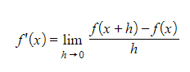
Reference [1]
Differentiation is used to find the gradient of a graph at any given point, so just substitute the x-coordinate given into the derivative to get the gradient at that coordinate. This is extremely useful as it does not require a tangent to be drawn but only the function to be known. An application is, differentiating a velocity-time graph, which gives the acceleration-time graph.

Integration uses the opposite operations of differentiation, instead, by going through each term, the power is increased by one then the whole term is divided by the power, then you move onto the next term. Additionally, a constant “C” is also added to the end. Regarding constants in integration, the become a coefficient of x (e.g., 10x+2 becomes 5x²+2x+C).
Like differentiation, this is also a shortcut, and the more formal rule is known as the integration power rule. And is stated as such:
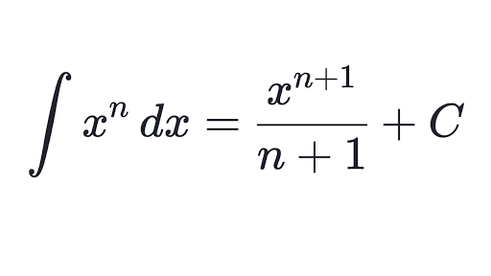
Reference [2]
Do note that this rule only works when n ≠ -1, this is because the remainder is zero and any number divided by 0 is undefined. Integration is used to find the area of a graph, however, in definite integrals, there are upper and lower limits. In this case, the C is ignored, then substitute the upper limit into the integration then subtract it by substituting the lower limit into the integration. This gives us the area under the given domain, which is especially useful, as it does not require us to draw shapes under a graph and approximate the area but rather, only the function needs to be known and the domain to integrate over. An application is integrating the acceleration-time graph which gives us velocity-time graph.

Logarithms (depicted as log) is used to solve exponential equations and logarithmic equations. Exponential equations are commonly used in real life, an application is the graph of radioactive decay which can be used to predict the half-life of an isotope. Logarithmic equations are also used to plot exponential equations linearly. An example is y=xª where a is the power and x is a constant can be rewritten as log(y) = a * log(x) so it can be plotted linearly where log(y) is the vertical axis, log(x) is the horizontal axis and a is the gradient.
Conversely, the equation log(y) = a * log(x) can be converted back into an exponential format by rewriting the equation as log(y) = log(xª) then removing the logs from both sides.

The Problems

1. Generation of questions

The issue is that although there exist many online websites that test the math skills by having a set quiz or a custom-made quiz, it requires the users to write down the questions themselves. Eventually, the users may not be able to think of any more questions. My solution is to randomly generate these questions infinitely if the player still has lives.

2. Difficulty of questions

The issue is that custom quizzes created online may not have a set difficulty. And even if they do, the jump from one difficulty to another may be immense. My solution is to create 3 difficulties (easy, medium, and hard) along with an adaptive difficulty that incorporates all 3 and generates the questions based on how well the user is performing.

3. Keeping track of user progress

Albeit online quizzes may have a leader board to show the top users who score the highest, they may not track the progress of their user. This is an important feature as it displays to the user visually if their skills are improving from the first time they played. My solution is to display a pie chart to show how well the users did before they lose all their lives in any difficulty. In the home page, there will be a separate section dedicated to leader boards showing the top 3 scores in their respective difficulties along with the user’s highest scores in them. It will also contain a graph showing their previous 10 scores regardless of the difficulties along with the date.

4. Non-computational problems

These are problems that cannot be solved by the computer, which may include writing words for a definite integration question which is supposed to have a numerical value. Alternatively, a user may directly integrate the definite integral given on their calculator instead of integrating first then substituting the values. The only way to fix these problems is to make sure the programs handle the invalid inputs correctly by displaying an error message instead of crashing. For the latter problem, there is no way to fix it, but it will only pose a problem for the user as they are hindering their own knowledge by solely relying on the calculator.

Researching the problem

1. My solution to the problem

My solution will be using the python language along with some static HTML and CSS for styling purposes. It will be implemented on the web via a python library called streamlit this will be used to create buttons, input fields and more in pythonic code which would otherwise require HTML along with JavaScript. There will be a login/register section for the user to log-in or register, the data entered will be stored in a .csv file and the password will be hashed by a simple implementation of the SHA-256 algorithm. Then, they will be redirected to the home page which will include the difficulties mentioned previously along with the leader boards and their personal records.

2. Existing solutions

An existing solution which is popular include quizzing platforms like Kahoot and Blooket, although these are not specifically targeted towards maths questions, they still allow users to create their own questions along with 4 options with one being the correct answer.
An example of a custom quiz made in Blooket is shown below.
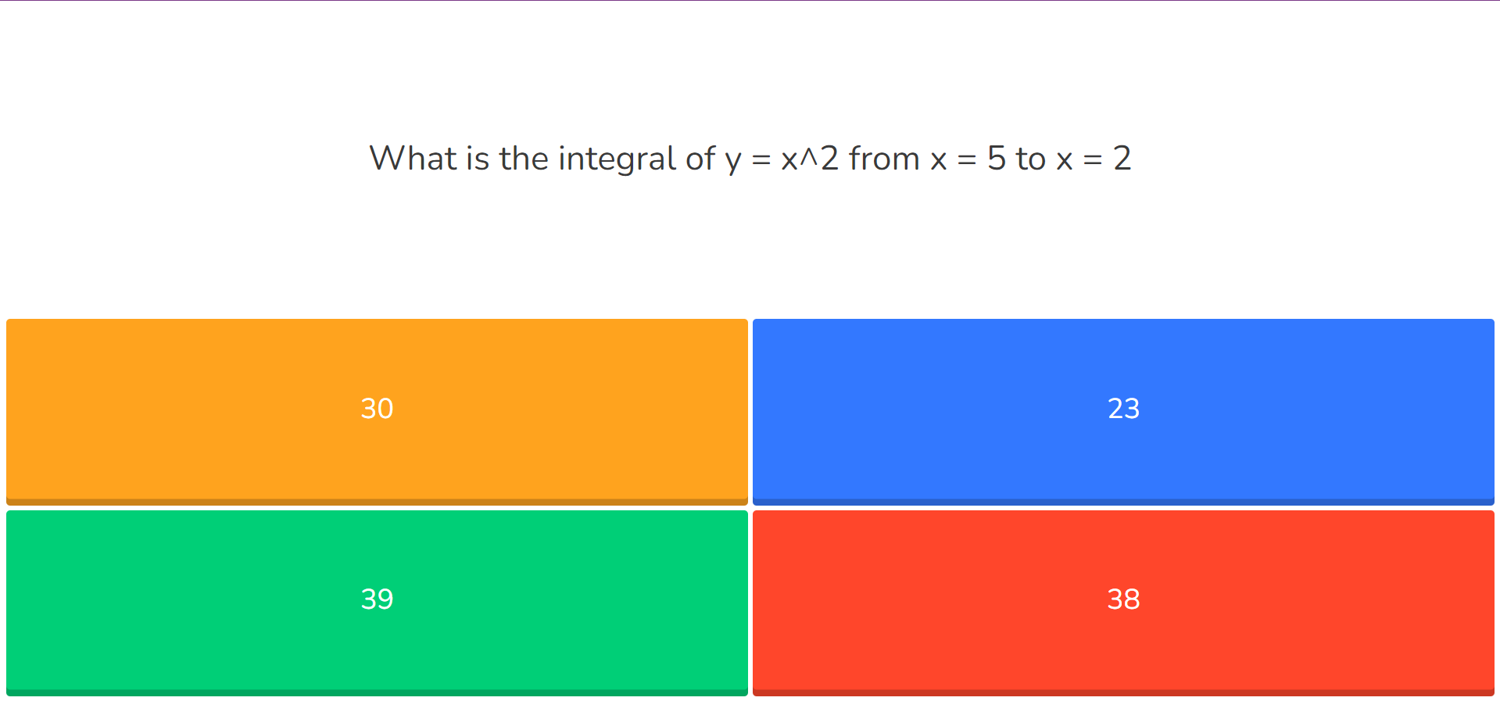
Reference [3]
While this is a good way to generate quick fire questions, it lacks the proper latex format for an integration sign and may confuse some users with symbols like “^” to represent powers.
Another website great for asking maths questions is Khan Academy. This is a website that teaches the fundamental maths skills for all age groups by creating videos. They also ask questions at the end of each lesson.
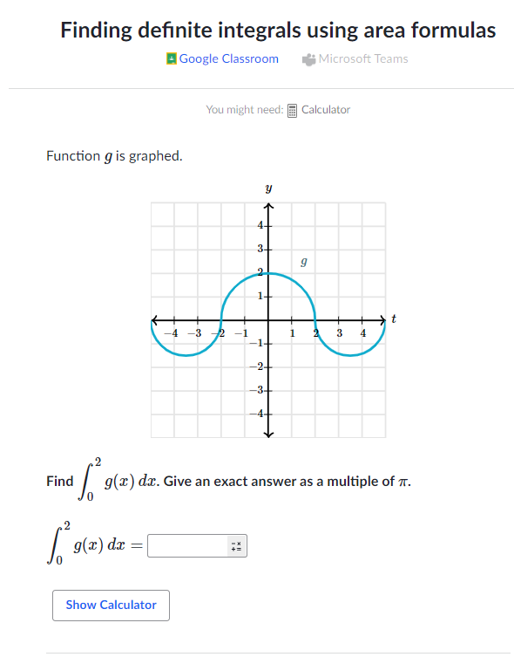
Reference [4]
While they provide a great platform to learn and practice maths skills, they don’t have an adaptive difficulty that incorporates all the new skills learnt. Additionally , there is no leaderboard and a graph containing the user’s progress over time.
To sum up my research , I haven’t found any website that can completely solve my problem However , as listed before , there are websites that can solve a part of the problem. Although the websites are well made and there is nothing inherently wrong with them, they lack some essential features that my stakeholder is looking for.

3. Key features of the solution

Fundamental features
- Allow the user to create an account and login with a pre-existing account. This feature is important as it enables the program to keep track of their record and hence display their progress on graph.

- Display a home page after logging in which allows the users to pick on of four options: easy, medium, hard and adaptive. This is so the users can pick the right difficulty to practice their maths skills on.

- Have a navigation bar and include a section that contains the leader boards for each difficulty scoring the top 3 highest scores, along with the user’s scores in those respective difficulties and a graph showing their progress

- Have a class called “EquationSolver” which is used to brute force all cases of a randomly generated medium difficulty question. Which are supposed to be generated in the form {rand_op} {num1} {rand_op2} {num2} = {num3}, where rand_op is a randomly selected operator from an array of operators and num is a randomly generated integer.

- Have functions to differentiate, integrate and perform logarithms. These functions will be stored in a dictionary the value and have a key corresponding to each. This is done to create a random key which will correspond to its value. Hence, randomly picking a function

- Have a class called “AdaptiveQuestions” which is used to generate the questions in adaptive difficulty. It looks at the average points scored in the previous games and using that, it sets the initial difficulty. Then, whenever a user gets an answer correct, 1 is added to an array else 0 is added. So, after every 5 questions, the sum of the array is used to determine the next difficulty the user should go to.

- Have a class called “SecurePassword” which is implemented using a simplified version of the SHA-256 algorithm to secure the user’s password by hashing it. The algorithm is simplified because it only handles passwords of lengths up to 55 characters.

- Generate a pie chart at the end of each difficulty to see how well the user did based on the difficulty.

- Send an email to the user’s email address to verify it’s them when logging in to their account

- Have two separate folders to store the user’s data, a folder which will contain the data of every user using the program and another to store the points and date of each user. This allows the information to be extracted and plotted as a graph.

Extra Features
- Considering to let the user change their password by using the email address they registered up with. Or, if they are already logged in then using the previous password they have entered

- Considering using a captcha bot to prevent bots from entering the website and launching an attack on it that may cause the server to crash.

- Considering adding indefinite integrals and antiderivatives of functions without an x-coordinate given

- Use some latex to properly format the correct notations and symbols when attempting the hard difficulty

4. Limitations of the solution
- Data is being stored on a csv file, so if there are many users using the website, then, it may take some time to search and find the specific user’s file.

- The CSS styling has only been tested on the chrome browser using a windows computer. Since the stylings aren’t responsive, it may negatively impact the user experience if they’re using other browsers or devices. (e.g. a mobile phone)

- The hashing algorithms implementation could be better by using a salt and using a different algorithm. An example is Argon2 that allows the programmer to slow down the hashing process, this is significant as it reduces the number of passwords guesses at a time. So, it will take hackers longer to guess the hash password.

- Random numbers generated by python’s random module are generated by an algorithm and could be guessed by hackers. A better library would be to use python’s secret module that creates cryptographically strong random numbers.

- It is deployed as a website so requires internet connection. If the users have no internet connection, then they can’t use the program.

5. Specify the proposed solution
- Making a login/register page

- Login page: Allow the user to enter their username and password. Using python’s module “pandas”, search through all the users held in a csv file “data.csv” which is in the folder “main_data”. Then, hash the password entered and compare it with the stored hashed password in the user’s csv file. If password or username is wrong flag an error, else direct them to the “verify” page

- Register page: Allow the user to enter their desired username, password and email address. If the username or email address already exists, then flag an error. Hash their password, then, write their details to the “data.csv” file. Additionally, make a separate csv file for them in the folder “user_data” using their username as the csv file. This will store their points and the date they got the point.

- Verify page: A code will be sent to the email address they registered with, then they must enter the code sent to continue to the home page. However, if they have already done this step before, then redirect them directly to the home page.

- Home page

- Add a top navbar that includes shows “Home” and “Leaderboards & Personal Record”. The home page will include options to select the 4 difficulties mentioned before. The Leaderboards & Personal Record page will include the leader boards along with the user’s personal record, and the graph that tracks their scores.

- Creating the difficulties

- Easy difficulty, users will be given questions in the format {num1} {rand_op} {num2} where all the variables are randomly generated. The program will know the answer by using pythons evaluate () function. All the answers will be rounded to 1 decimal place, additionally num1 and num2 will be randomly generated depending on the operator chosen. If operator is “/” or “*”, then generate the numbers such that 1 ≤ number ≤ 10 else, 1 ≤ number ≤ 100.

- Medium difficulty, users will be given questions in the format {rand_op} {num1} {rand_op2} {num2} = {num3} where all the variables are randomly generated. The program will know the answer by using a custom-made class “EquationSolver” that brute forces all cases. The questions generated will be in a while loop as it is possible to get a ZeroDivisionError, so in this case, generate a new question. All the answers will be rounded to 1 decimal place and the numbers will be generated such that 1 ≤ number ≤ 10.

- Hard difficulty, users will be given random calculus questions. There are 4 types of calculus questions: Integration, Differentiation, Exponential and Logarithmic questions.

For integration, the numbers will be generated such that 1 ≤ upper_interval ≤ 10, -10 ≤ lower_interval ≤ -1, 6 ≤ first_x_power ≤ 9 and 2 ≤ second_x_power ≤ 5. The program will know the answer by integrating the question generated then substituting the intervals and subtract them.

For differentiation, the numbers will be generated such that 6≤ first_x_power ≤ 9, 2 ≤ second_x_power ≤ 5, 1 ≤ x_coordinate ≤ 10. The program will know the answer by differentiating the question generated then substituting the x-coordinate.

For exponential questions, the question will be generated in the format {base}^x = {ans} where 2 ≤ base ≤ 10 and ans is a randomly generated decimal from 1 to 10 rounded to 1 decimal place. The users will have to solve for x, the program will know the answer by using logs on both side and dividing them.

For logarithmic questions, the questions will be generated in the format log_{{base}}(x) = {exponent} where 2 ≤ base ≤ 9 and 0 ≤ exponent ≤ 20. The users will have to solve for x, the program will know the answer by raising the base to the exponent.

All the questions mentioned above will be rounded to the nearest 1 decimal place and have proper latex formatting. They will be implemented as functions and stored in a dictionary along with their key name. This is so that a random key from the dictionary can be selected and generate the random calculus question based on the key’s value.

- Adaptive difficulty, the initial difficulty will be set by considering the average of the total points scored by the user previously. This data will be extracted from the folder “user_data” from the csv file that has the same username. Every 5 questions, the difficulty may change depending on how well they do. The questions will be generated by a custom class “AdaptiveQuestion” which will contain all the previous difficulties, will be responsible for finding the average of the total points and change the questions depending on how well the user is performing. This will be done by finding the sum of an array, if the user answers correctly, then add 1 to the list, else add 0 to the list.

- (Optional) making a different difficulty where users will have to solve indefinite integrals and derivatives.

- Handling user data

- The password will be hashed by a custom class “SecurePassword” which will use the SHA-256 algorithm.

- Whenever, the user refreshes the page or attempts to access another page while not logged in, direct them to the “error” page. This will give an option to redirect to the log-in page

- If the user presses the back button provided by the browser while in a game mode, handle the data correctly by deleting specific session state data.

6. Success criteria
- User data is saved correctly, and a code is sent to their email address
- Program correctly generates random questions and have the correct answers for them
- Program does not crash when user refreshes or presses the back button on the browser
- Program flags an error when an incorrect data type is entered as an answer
- Will the users be able to know what they’re supposed to solve for?
- Is this solution better than existing solutions?

Design of the solution

Functional Decomposition
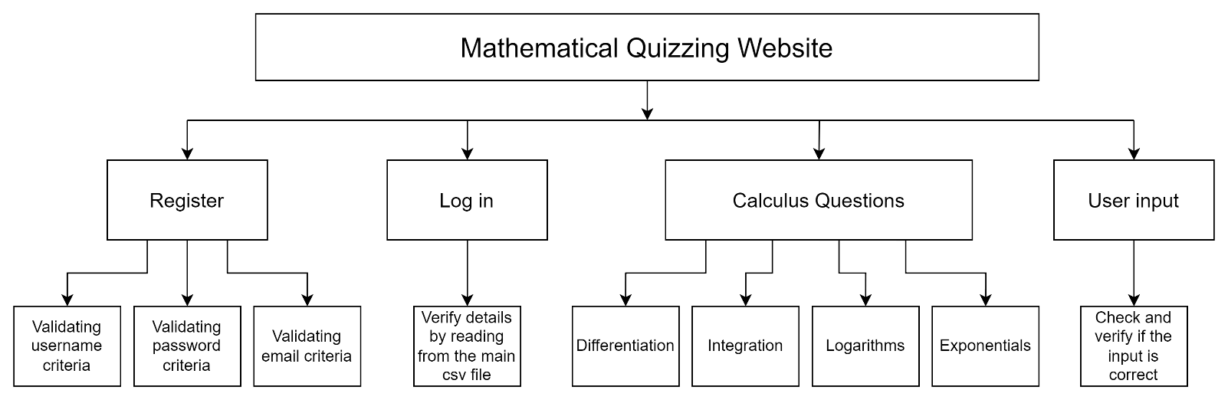

The solution has been split into 5 main parts , each of which (except for user input) will have their own page, each level below will briefly describe the functions they are supposed to perform.

Register page has been split into validating username, password and email address based on a specific criterion. Once all the criteria have been met, the program will save the details by writing to a main csv file and creating another csv file under the username registered with.

Log in page has been split into verifying if the username and password entered is correct along with sending a pin to the email address, they registered with to verify that the account belongs to them.

Calculus-based questions used in hard and adaptive difficulty have been split into differentiation, integration, exponentials and logarithms. These will generate a random question along with the correct answer.

User input will concentrate on the input given while playing the game modes, it is used to make sure the program won’t crash if an unexpected data type is entered.

Algorithms
Validating username for register page:
Function is_username_valid(username)
If is_username_unique(username) == False then
return False and the error message “Username already taken”
elseif has_invalid_chars(username) == True then
return False and the error message "Username can only be 3-20 chars long"
elseif only_numbers(username) == True then
// This is to prevent users from entering their
// personal info like mobile phone number
return False and the error message “Username may contain private information"
elseif username.length < 4 then
return False and the error message “Username must be longer than 3 chars”
elseif only_one_underscore(username) == False then
// Prevents username from only having underscores
// in them
return False and the error message "Username may at most have one underscores in them”
else
return True and an empty message to indicate the username has passed all the criteria above
endif
endfunction
This function, which has been slightly simplified by not including the code of the other functions used to perform the checks is the rough idea of how the program will check if the username is suitable. This is to ensure that the username is not too short when displaying and helps keep it secure.

Validating password for register page:
Function is_password_valid(password)
If has_special_chars(password) == False then
return False and the error message "Password must have a special character"
elseif has_lower_chars(password) == False then
return False and the error message "Password must have at least 1 lowercase letter"
elseif has_upper_chars(password) == False then
return False and the error message "Password must have at least 1 uppercase letter"
elseif password.length < 8 then
return False and the error message "Password must be at least 8 characters long"
else
return True and an empty message to indicate the password has passed all the criteria above
endif
endfunction

This function, which has been slightly simplified by not including the code of the other functions used to perform the checks is the rough idea of how the program will check if the password is suitable. Although the password will be hashed when saving to the csv files, a strong and secure password will make it harder to be cracked via a brute force attack or other methods to steal the user’s password.

Validating email for register page:
Function is_email_valid(email)
If does_email_exist(email) == False then
return False and the error message “Email does not exist”
elseif is_email_taken(email) == True then
return False and the error message “Email already in use”
else
return True return True and an empty message to indicate the email has passed all the criteria above
endif
endfunction

This is a very simple function which will be using an in-built library provided by python to check if the email exists. However, it won’t be able to verify if the email belongs to the user, so it is important that the users provide an email address they have access to so they can receive messages later.

Functions needed for log in page:
Function does_username_exist(username):
// Checking if the user has typed something
If username then
data = openRead(“main_data.csv”)
return True if the username exists in the data, else return False
else
return False
endif
endfunction

Function is_password_correct(username , password):
// Try block is needed to prevent program from crashing // if the username does not exist
Try
data = openRead(“main_data.csv”)
// Gets stored password based on username
stored_password = get_password(main_data,username)
if hash(password) == stored_password then
return True
else
return False
endif
// Catching errors
catch IndexError
return False
endfunction

These functions are rough ideas as to how the program will check if the account exists and that they have the correct password to access it. For the second function, the password entered must be hashed because the password stored has also been hashed.

Differentiation function for calculus questions:
Function differentiate
// In-built function RandomNumber is to generate a random number between 2 ranges (Both inclusive)
value_x = RandomNumber(1,10)
bigger_power = RandomNumber(6,9)
lower_power = RandomNumber(2,5)
// Using latex formatting, formats the equation
// appropriately to avoid any confusions for the user
equation = convert_to_latex(value_x , bigger_power , lower_power)
upper_derivative = bigger_power * value_x ** (bigger_power – 1)
lower_derivative = lower_power * value_x ** (lower_power -1)
answer = upper_derivative + lower_derivative
// Round function rounds floats to a certain d.p
return equation, round(answer,1)
endfunction

For the sake of simplicity, differentiation questions will look something like (x^{pow1} + x^{pow2}) where the operator doesn’t change but the powers and x-values are randomly generated. This is a rough sketch as to generating random differentiation questions.

Integration function for calculus questions:
Function integrate
// In-built function RandomNumber is to generate a random number between 2 ranges (Both inclusive)
upper_interval = RandomNumber(1,10)
lower_interval = -RandomNumber(1,10)
bigger_power = RandomNumber(6,9)
lower_power = RandomNumber(2,5)
// Using latex formatting, formats the equation
// appropriately to avoid any confusions for the user
equation = convert_to_latex(upper_interval , lower_interval , bigger_power , lower_power)
bigger_power = bigger_power + 1
lower_power = lower_power + 1
upper_antiderivative = (upper_interval**bigger_power) / bigger_power + (upper_interval**lower_power) / lower_power
lower_antiderivative = (lower_interval**bigger_power) / bigger_power + (lower_interval**lower_power) / lower_power
answer = upper_antiderivative – lower_antiderivative
// Round function rounds floats to a certain d.p
return equation, round(answer , 1)
endfunction

For the sake of simplicity, integration questions will look something like (x^{pow1} + x^{pow2}) where the operator doesn’t change but the powers, x-values and the intervals are randomly generated. This is a rough sketch as to generating random integration questions.

Logarithms function for calculus questions:
Function logarithms
// In-built function RandomNumber is to generate a random number between 2 ranges (Both inclusive)
base = RandomNumber(2,9)
exponent = RandomNumber(0,20)
// Using latex formatting, formats the equation
// appropriately to avoid any confusions for the user
equation = convert_to_latex(base , exponent)
answer = base ** exponent
// Round function rounds floats to a certain d.p
return equation , round(answer , 1)
endfunction

This will be a relatively simple function to generate random logarithmic questions.

Exponential functions for calculus questions
Function exponents
// In-built function RandomNumber is to generate a random number between 2 ranges (Both inclusive)
base = RandomNumber(2,10)
// Function RandomFloat is to generate a random float between 2 ranges (Both inclusive) to 1 d.p
result = RandomFloat(1,9)
// Using latex formatting, formats the equation
// appropriately to avoid any confusions for the user
equation = convert_to_latex(base , result)
// In-built function Log is to return the natural logarithm of a value
answer = Log(base) / Log(result)
// Round function rounds floats to a certain d.p
return equation , round(answer , 1)
endfunction

This will be a relatively simple function utilising a math library from python to get the logarithms of numbers. This will be used to generate random exponential questions.

Function to check user input when playing:
Function check_type(answer , type)
If str(answer).count(“-“) == 1:
// Essentially removes the negative sign
answer = answer[1:]
endif
Try
// The parameter type is given as a data type (only // int or float) this code attempts to change the
// data type of answer to the data type provided
type(answer)
return True
// If failed to change the data type (e.g. Trying to
// convert “Hello” to int) then this block of code is
// executed
catch (ValueError)
return False
endfunction
This function is very essential as it prevents the program from working incorrectly. When retrieving the answer from the input box, it will always be a string, hence, python’s in-built “Is_instance()” function cannot be used (as Is_instance(user_answer, int/float) will always be false) .

Flowcharts

Register page
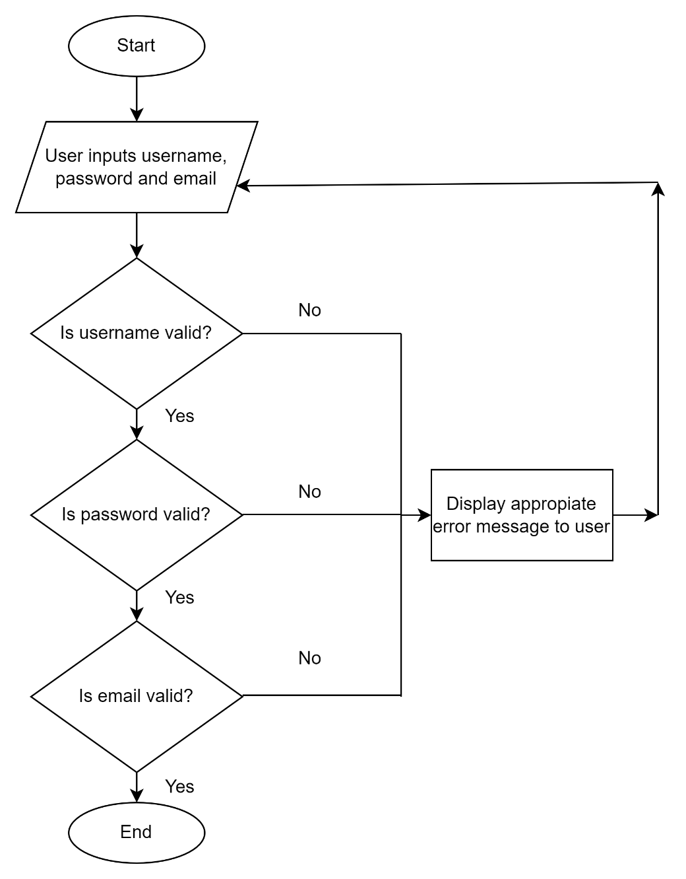

Login page
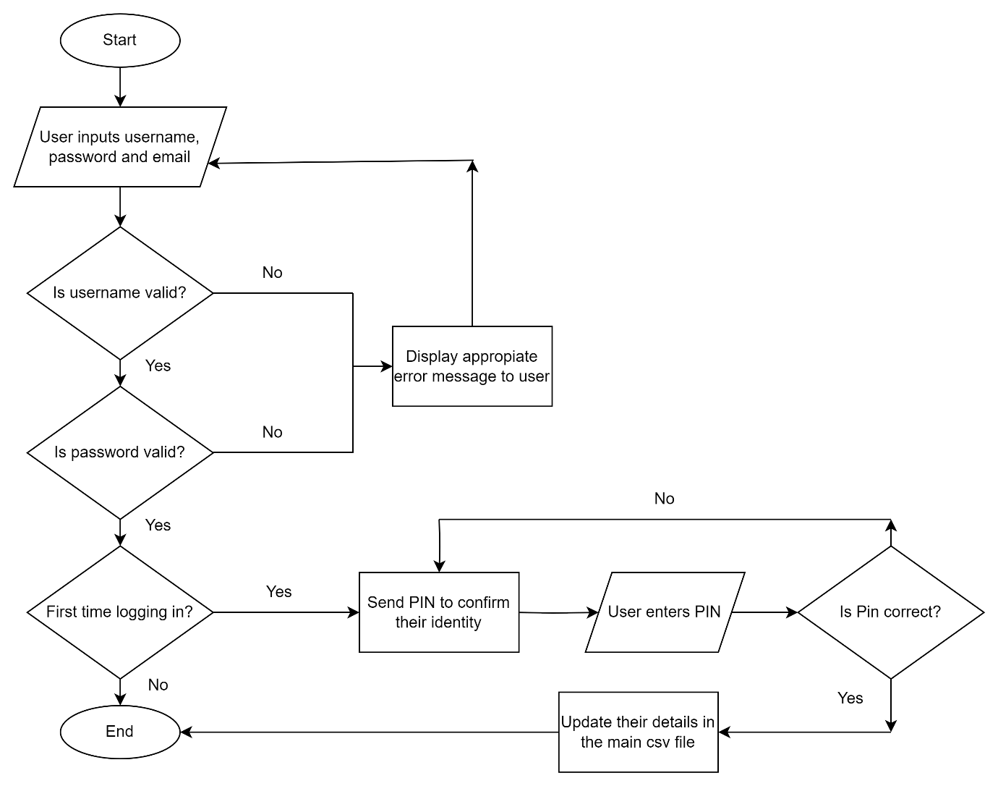

Calculus Questions for Hard difficulty Page
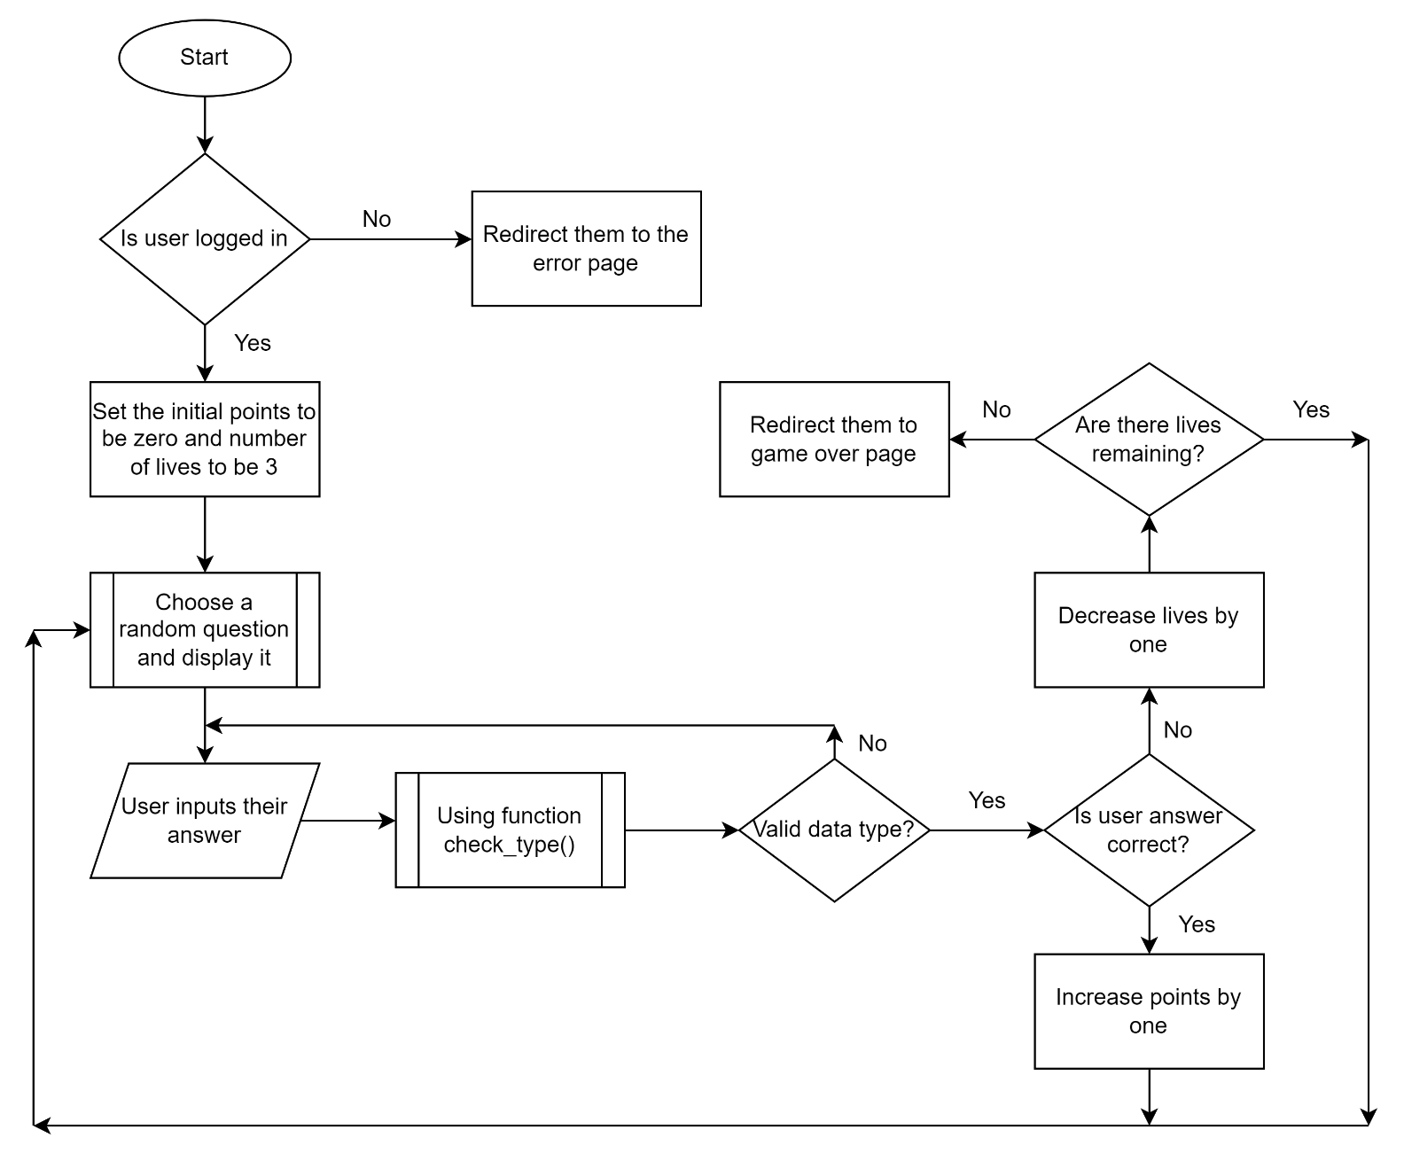

Register page initial design
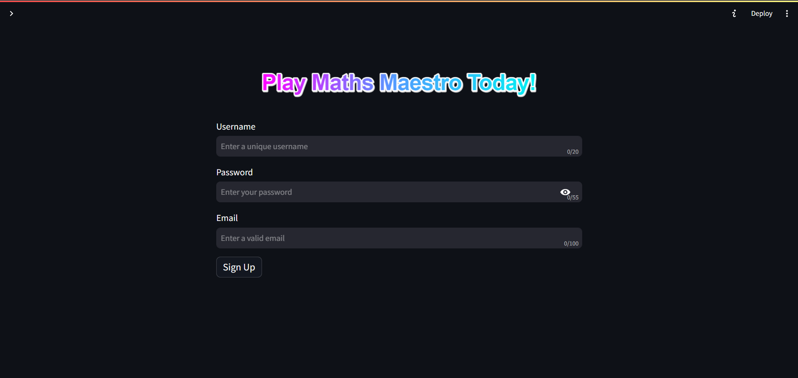
This is what my register page will mostly look like, some CSS may be implemented later to make the design neater. Additionally, options like “Already have an account?” may be added later to the design to improve the user experience.

Login page initial design
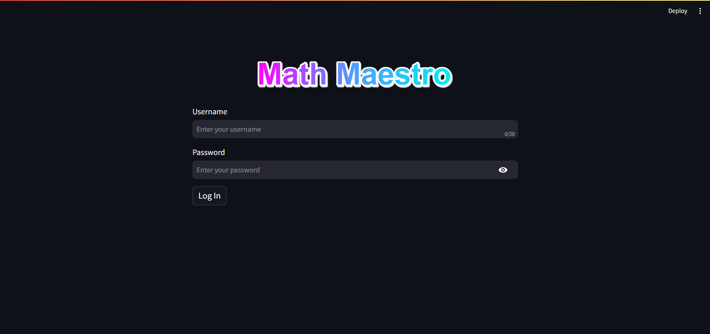
This is what my login page will mostly look like, some CSS may be implemented later to make the design neater. Additionally, options like “Forgot password?” or “Don’t have an account?” may be added later to the design to improve the user experience.

Calculus Questions for Hard Difficulty initial design
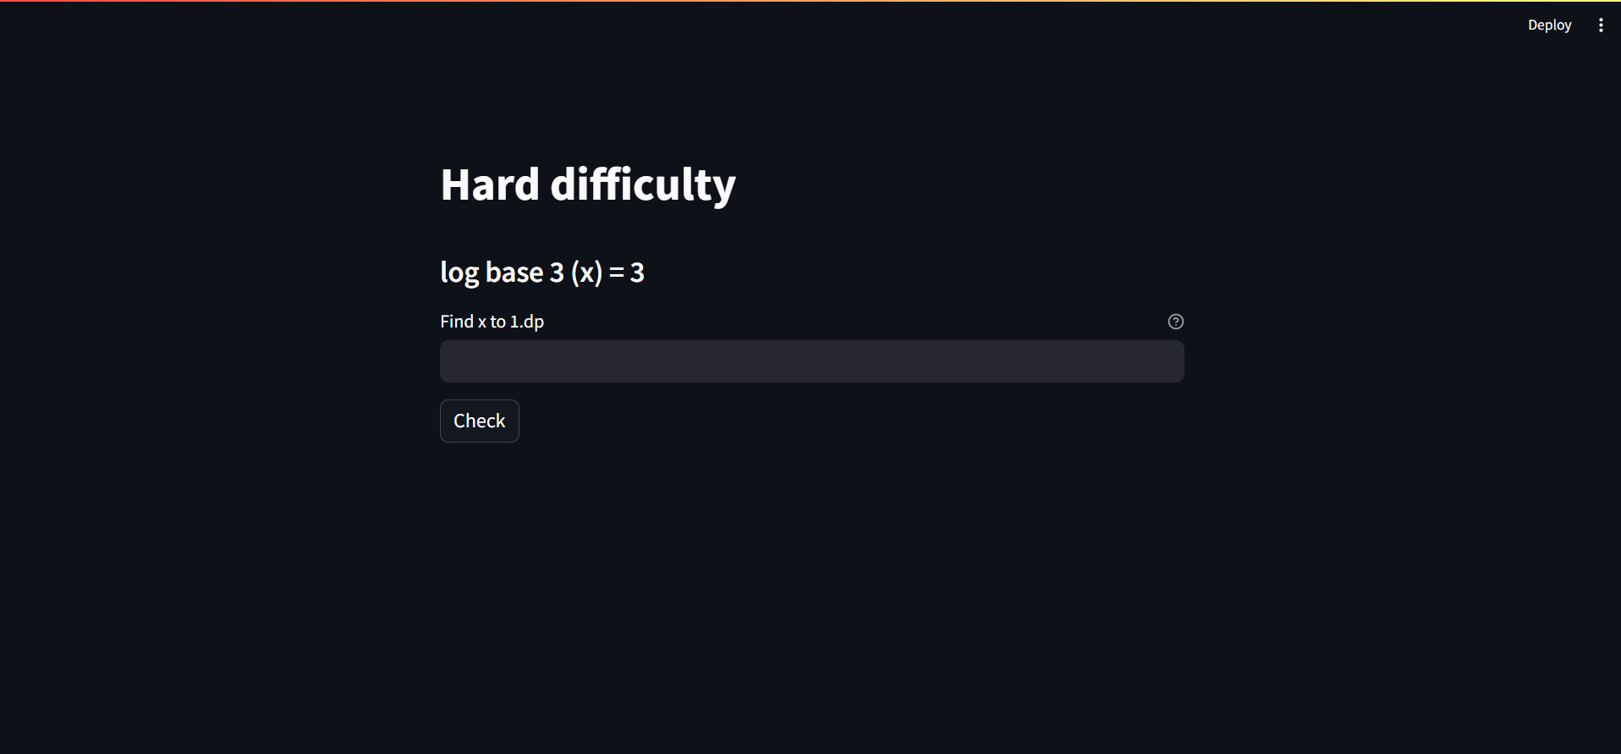
This is what my hard difficulty page will mostly look like, some CSS may be implemented later to make the design look neater. As mentioned before, the latex formatting for the questions will also be implemented later.

Development of the solution

During development

During development, the tests created will be used to check if the program works as intended and observing the outcomes. For login and register page, tests such as inputting invalid characters, using a different font etc... will be used to check if the program can identify the errors and flag, it as an error message to the users. For the different difficulties, tests such as inputting a string instead of an integer, inputting “1.0000000” instead of “1” etc…. will be used to check if the program can identify the errors and flag, it as an error message to the users. There will also be multiple other aspects such as preventing the user from directly navigating to a page without logging in and handling the pages correctly if the user presses the back button on a website which will be tested alongside. However, before testing, I will focus on the CSS aspect of the website along with latex formatting to help the website look better

Development and Testing logs
Date: 01/09/2024 – 05/09/2024

What is being tested? Nothing, the time spent was used to learn CSS, Latex, Pandas and Streamlit to integrate them into the solution

Details about the code: N/A

Outcome of the test: N/A

Approach to fix the problem: N/A
Date: 06/09/2024

What is being tested? Development of register page. Designing the page and testing the user inputs for it.

Details about the code:
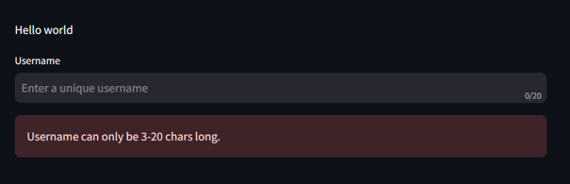

Outcome of the test: The program has already flagged an error message to the user even though there is no input

Approach to fix the problem: Now within the function, it checks for the presence of an input provided by the user using a simple if condition. The code is shown below:
Date: 07/09/2024

What is being tested? Development of register page. Making the username criteria mentioned before in pseudocode and testing them out

Details about the code:
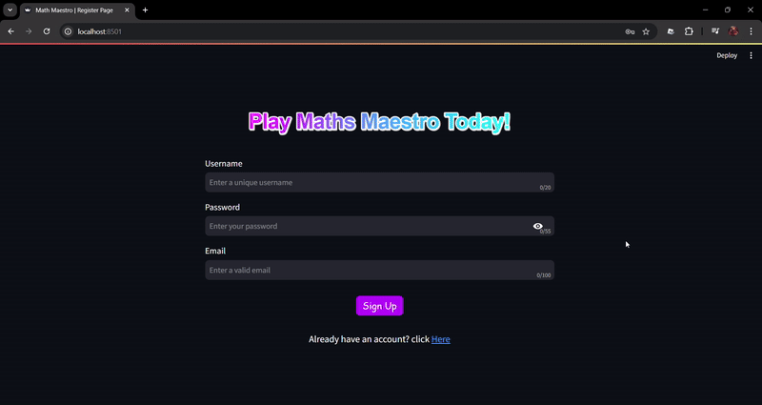

Outcome of the test: Test was successful as there was no error spotted and the program worked as expected

Approach to fix the problem: N/A
Date: 08/09/2024

What is being tested? Development of register page. Making the email criteria mentioned before in pseudocode and testing them out

Details about the code:
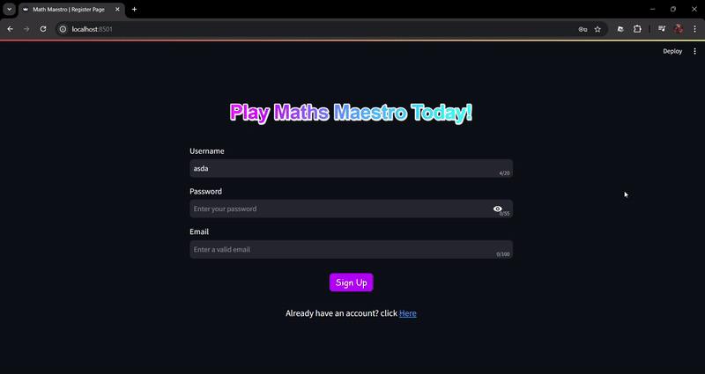

Outcome of the test: Test was successful as there was no error spotted and the program worked as expected

Approach to fix the problem: N/A
Date: 09/09/2024

What is being tested? Development of register page. Making the email criteria mentioned before in pseudocode

Details about the code:
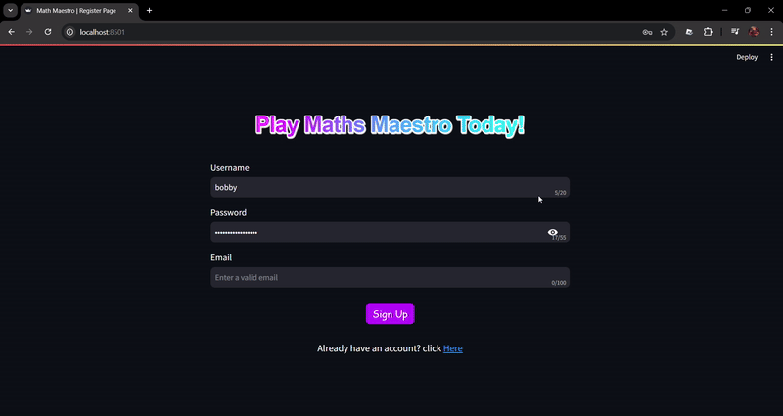
Outcome of the test: Test was successful as there was no error spotted and the program worked as expected

Approach to fix the problem: N/A
Date: 10/09/2024

What is being tested? Register page has been fully developed, now testing to see if the program works as intended and allows the user to create an account

Details about the code:

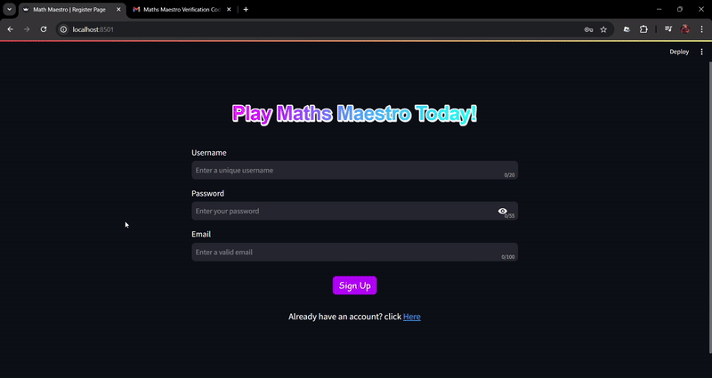

Outcome of the test: The test was successful as the data of the users have been saved into the main csv file as shown below:

Additionally, the user also has their own csv file now, this will be used in the future to plot the graphs showing their growth
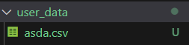

Approach to fix the problem: N/A
Date: 10/09/2024

What is being tested? Development of the class SecurePassword which uses the SHA-256 hashing algorithm. The development will be done by using a YouTube tutorial (https://www.youtube.com/watch?v=orIgy2MjqrA). Testing the sigma_zero function which is a part of the hashing algorithm.

Details about the code:
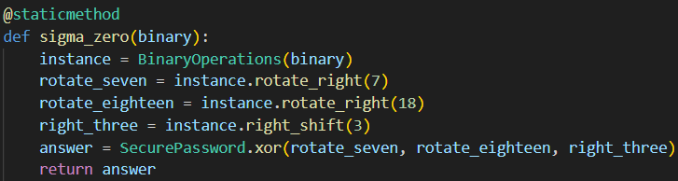
Output:

Expected Output (Final line):

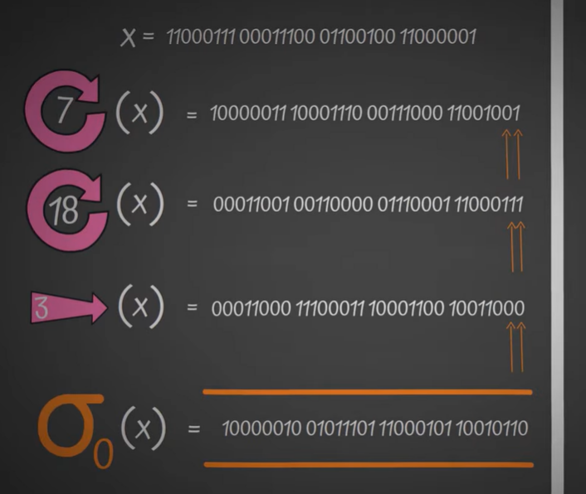

Outcome of the test: Although I had followed the video step by step, there seems to be a logic error in the function coded.

Approach to fix the problem: Through intensive research and use of ChatGPT (Reference [5]) to debug the function, it turns out it was an error on the animator’s side for showing the wrong binary number as shown in the comment below.
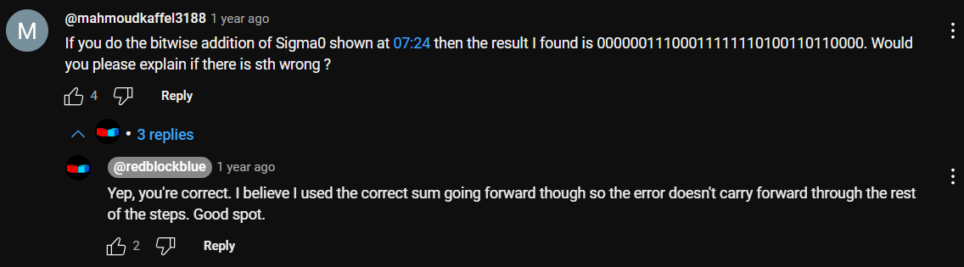
Date: 11/09/2024

What is being tested? Development of the class SecurePassword which uses the SHA-256 hashing algorithm. The class has been fully implemented now, using test cases to see if the algorithm works.

Details about the code:
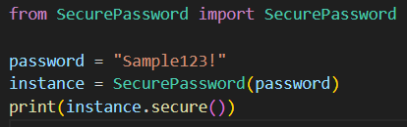
Output:

Outcome of the test: The password has been successfully hashed and is now secure enough to be stored in csv files

Approach to fix the problem: N/A
Date: 11/09/2024

What is being tested? Development of login page. Testing if program can allow users to login to the website

Details about the code:

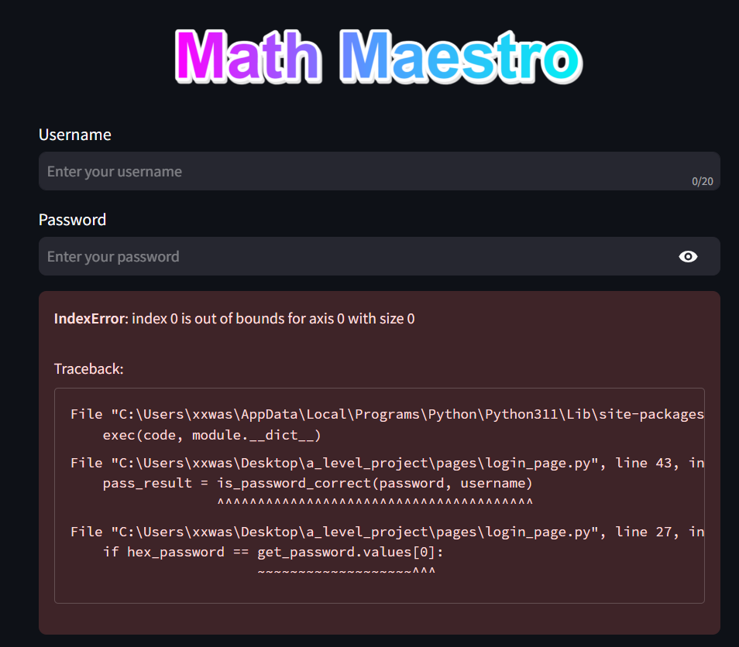

Outcome of the test: Although the users haven’t entered anything, an error message has already been flagged, this is happening because an empty username doesn’t exist in the main csv file. So, the python module pandas will retrieve an empty array. Hence, trying to access an empty array raises this error

Approach to fix the problem: A try-except block is needed to catch any errors in case there’s an empty username. The fixed code is shown below:
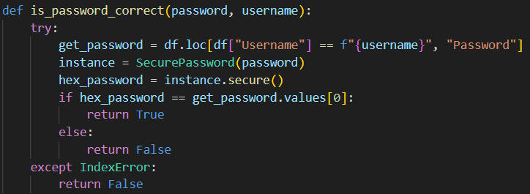

Date: 12/09/2024

What is being tested? Development of the “Forgot Password?” section, will be testing to see if the users get the email and if the PIN provided works.

Details about the code:

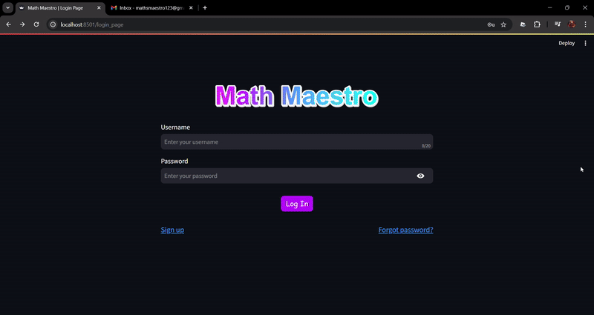

Outcome of the test: The users receive the 6-digit PIN, and the program correctly identifies it. The same concept will be used to verify the users when logging in for the first time.

Approach to fix the problem: N/A
Date: 12/09/2024

What is being tested? Development of the “401 Error” section, will be testing to see if it prevents users from directly navigating to a certain page.

Details about the code:

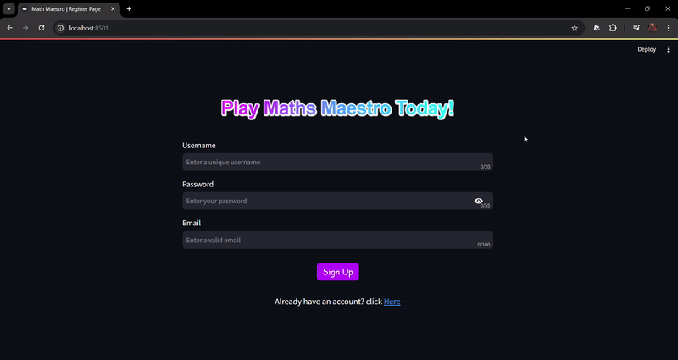

Outcome of the test: The users are redirected to an error page when attempting to directly navigate to a page. This is essential as the program may crash if a user without logging in tries to play a game or view the leaderboard.

Approach to fix the problem: N/A
Date: 13/09/2024

What is being tested? Log-in page has been fully developed, now testing to see if the program allows users to log in as intended.

Details about the code:

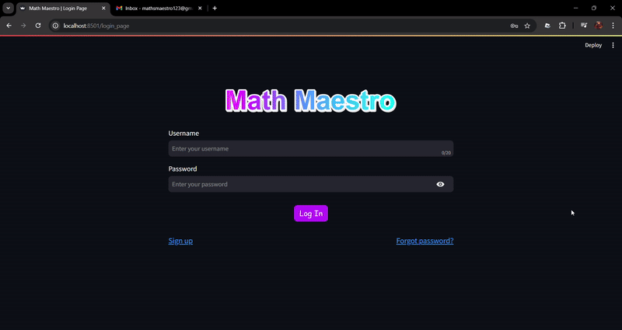

Outcome of the test: The test was successful as it allows the users to log in. Additionally, the main csv file has been slightly modified from last time, it now stores the hashed password instead of raw password. After the first log in, “Verified” column will be updated from False to True, this means the user won’t need to verify via email again when logging in.

Additionally, the design for home page has already been implemented as shown in the GIF above
Approach to fix the problem: N/A
Date: 14/09/2024

What is being tested? Development of easy difficulty. Testing to see if user input is allowed and works correctly.

Details about the code:

First test (testing invalid inputs):
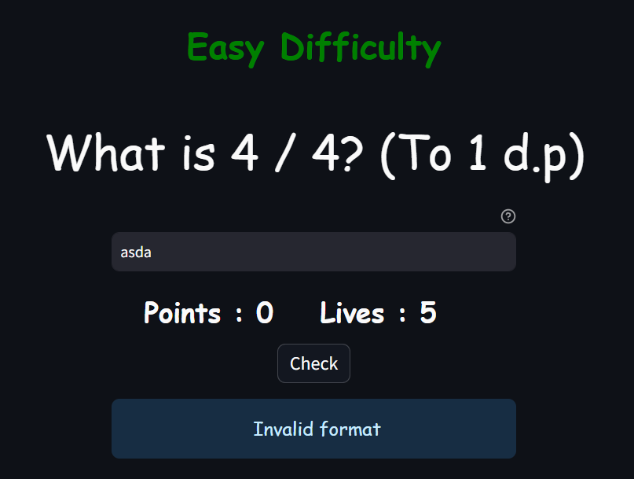

Second test (testing correct and incorrect answers):
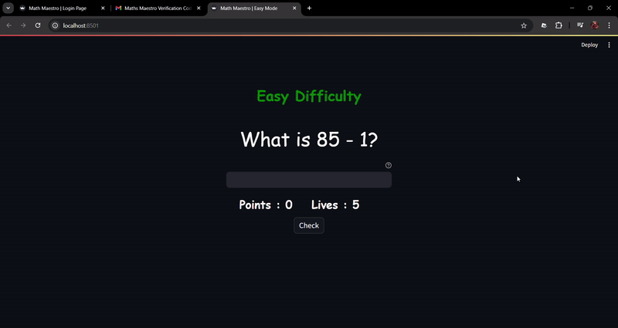

Outcome of the test: Successfully displays the questions to the user and randomly generates them. Although the first test has been passed, the second test failed. This is probably because the user’s input is still a string when comparing with the correct answer which an int/float.

Approach to fix the problem: Cast the user answer from string type to int/float type as needed appropriately.
Date: 14/09/2024

What is being tested? Development of easy difficulty. Now making the “game over” page which the users will be redirected to after losing all lives

Details about the code:

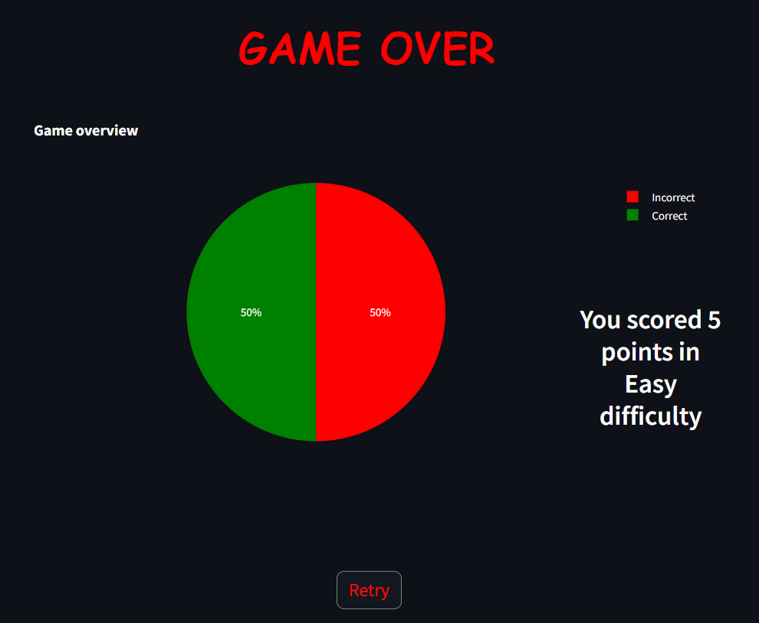

Outcome of the test: No test required as it’s designing the game over page.

Approach to fix the problem: N/A
Date: 15/09/2024

What is being tested? Development of easy difficulty. Testing to see if the program goes to “game_over” page after 0 lives.

Details about the code:

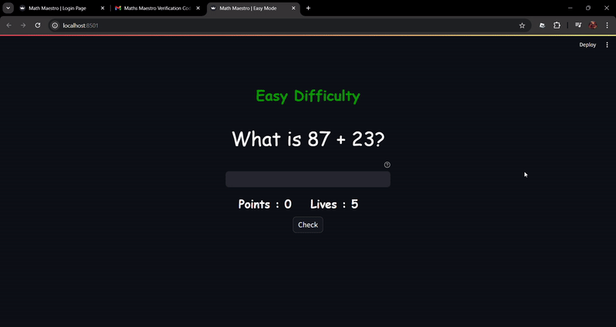

Outcome of the test: The user is successfully redirected to the game over page which has a pie chart showing how many questions they got right.

Approach to fix the problem: N/A
Date: 15/09/24

What is being tested? Development of easy difficulty. Testing to see how the program reacts when replaying the same game mode.

Details about the code:
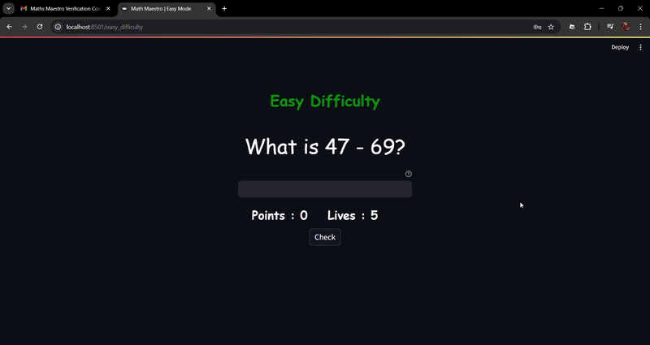

Outcome of the test: The test shows that the program has a logic error as the lives start at 0 when replaying. Then, it goes into the negatives when getting questions wrong.

Approach to fix the problem: This issue was solved by promptly deleting the session states of easy difficulty. The code is shown below:
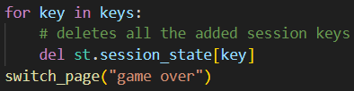
Date:15/09/2024

What is being tested? Development of medium difficulty. Currently making the class EquationSolver which will be used to get the answers to the randomly generated questions. This will be done via a brute-force approach.

Details about the code: N/A

Outcome of the test: N/A

Approach to fix the problem: N/A
Date: 16/09/2024

What is being tested? Development of medium difficulty. The class EquationSolver has been fully designed and implemented now, testing to see if the program displays the question to the user

Details about the code:
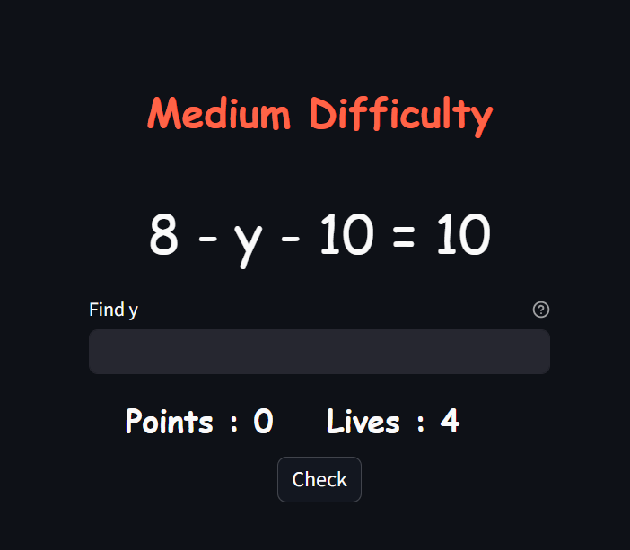

Outcome of the test: Successfully made the code to randomly generate medium level difficulty questions and display them.

Approach to fix the problem: N/A
Date: 16/09/2024

What is being tested? Development of medium difficulty. Testing to see if the program works as intended and redirects to points page when lives reach 0

Details about the code:

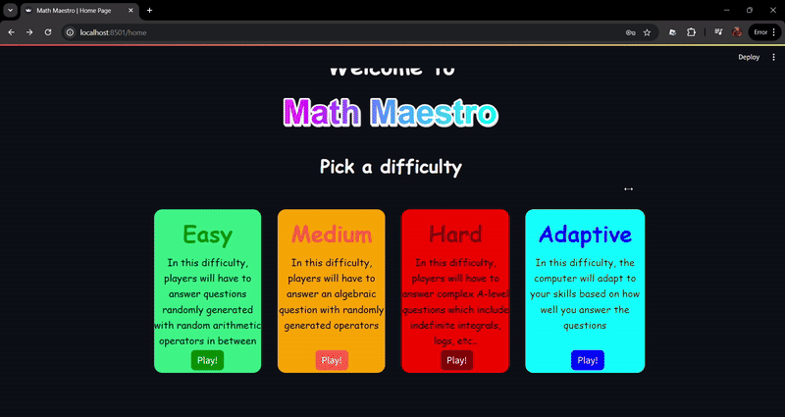

Outcome of the test: The user is successfully redirected to the game over page which has a pie chart showing how many questions they got right.

Approach to fix the problem: N/A
Date: 17/09/2024

What is being tested? Development of medium difficulty. Testing to see how the program reacts when switching from one difficulty to another (e.g. From easy difficulty to medium difficulty)

Details about the code:

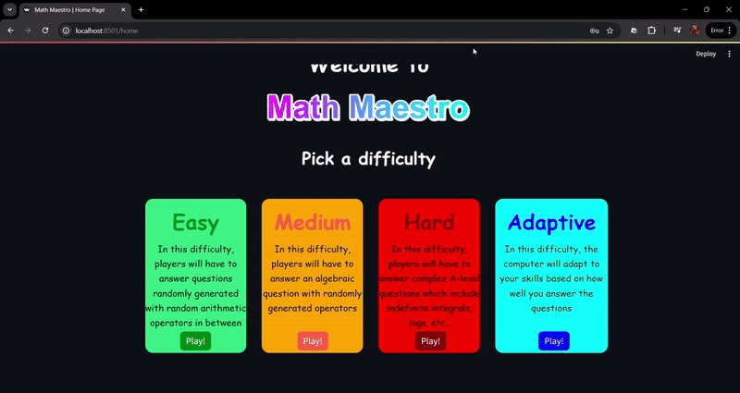

Outcome of the test: If the user decides to switch difficulties in the middle of playing one, the program crashes as different game modes will have different session states.

Approach to fix the problem: This issue was solved promptly by assigning a new session state “playing” that is used to check if a user is currently playing a difficulty. The code is shown below:

Home page:
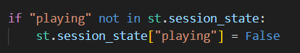

Medium difficulty page (same code will be implemented for all difficulties):
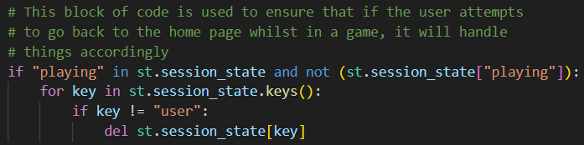
Date 17/09/2024:

What is being tested? Development of hard difficulty. Currently designing and implemented the pseudocodes for calculus questions mentioned before. This will not be done in a class but rather in the same file, this is because the answer can be easily obtained for any random question.

Details about the code: N/A

Outcome of the test: N/A

Approach to fix the problem: N/A
Date 17/09/2024:

What is being tested? Development of hard difficulty. The calculus questions have been implemented and now testing to see if the latex presents the questions correctly.

Details about the code:

Latex for integrals:
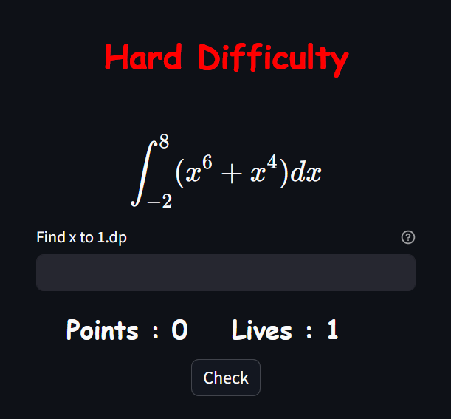

Latex for logarithms:
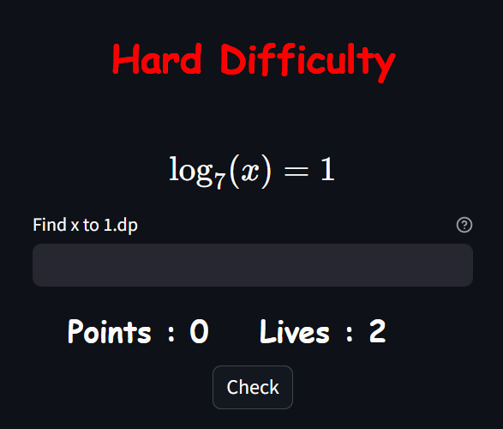

Latex for differentiation:
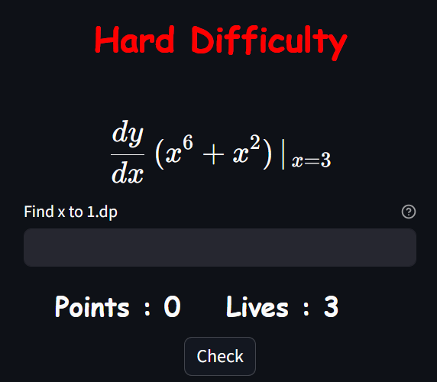
Latex for exponents:
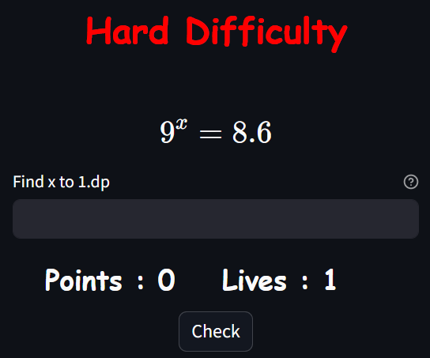

Outcome of the test: The test was successful as the latex seems to be working perfectly fine. This will be essential to users as using signs such as ** to indicate powers could be confusing.

Approach to fix the problem: N/A
Date 17/09/2024:

What is being tested? Development of hard difficulty. Testing to see if the program works as intended and redirects to points page when lives reach 0

Details about the code:

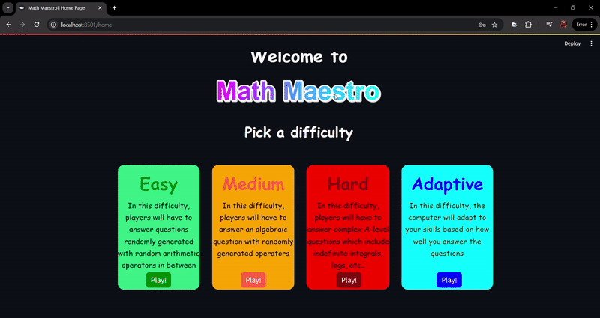

Outcome of the test: The user is successfully redirected to the game over page which has a pie chart showing how many questions they got right.

Approach to fix the problem: N/A
Date: 18/09/2024

What is being tested? Storing the points the users get after the finish a difficulty into their personal csv file and the main csv file. The user’s best attempt at each difficulty will be stored in the main file whilst in the personal file, all the points will be recorded.

Details about the code:

Saving the points into a csv file (The code is the same for all the difficulties):
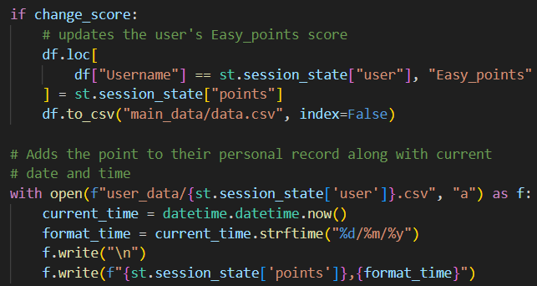

Outcome of the test: The test was successful as the user’s data has been successfully saved into the csv file as shown below.

Personal csv file (for user JohnDoe):
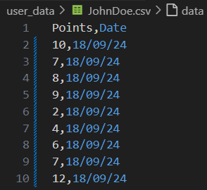

Main csv file:
This image also shows that the main csv file only saves the best scores in each difficulty as in the previous image, all the points were scored in easy difficulty.

Approach to fix the problem: N/A
Date: 18/09/2024

What is being tested? Development of adaptive difficulty. Currently making the class AdaptiveQuestions, which will include the code that randomly generates questions and answers from all the previous difficulties. In this class, the average of the user’s past scores will be used as a baseline to generate the initial difficulty. After every 5 questions, the number of correct answers will be tallied up and the program will check if the difficulty needs to be increased.

Details about the code: N/A

Outcome of the test: N/A

Approach to fix the problem: N/A
Date: 18/09/2024

What is being tested? Development of adaptive difficulty. The class AdaptiveQuestions has been fully developed, now testing if the program correctly sets an initial difficulty.
The program sets an initial difficulty by using the average of all the user’s previous score.
If avg_score > 10 then initial difficulty will be hard, if it’s > 5 then medium difficulty, else it will be easy difficulty.

Details about the code:

Test case 1:
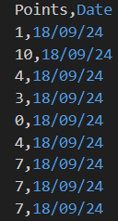
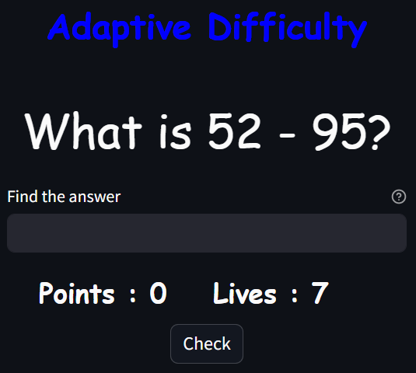

Test case 2:
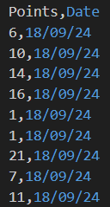
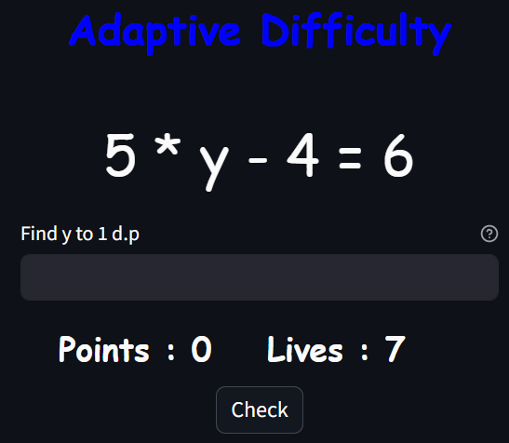

Test case 3:
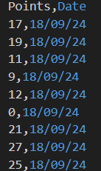
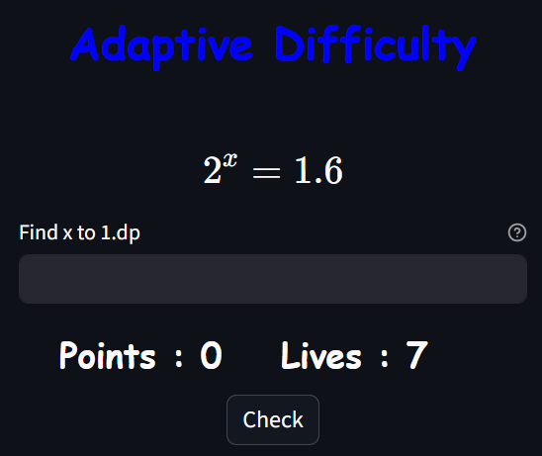

Outcome of the test: The test was successful and shows that the initial difficulty is correctly being calculated and displayed.

Approach to fix the problem: N/A
Date: 19/09/2024

What is being tested? Development of adaptive difficulty. In the class AdaptiveQuestions, after 5 questions, if the user gets all of them correct, move them to the hard difficulty. If the get more than 3 questions correct, move them to the medium difficultly else, go to easy difficulty.

Details about the code:

Test case 1 (Easy -> Hard):
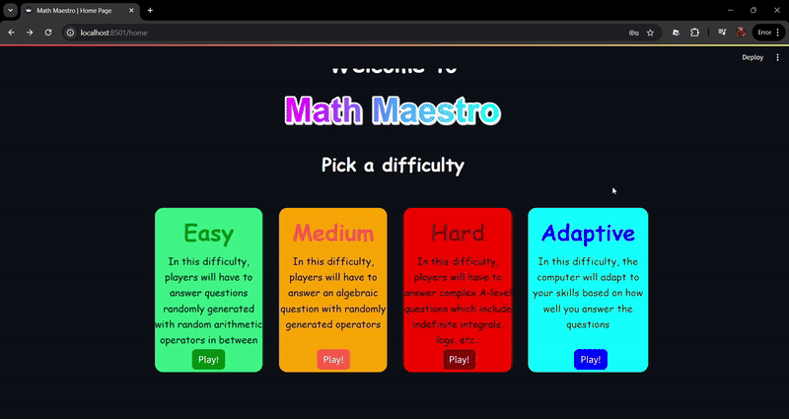

Test case 2 (Medium -> Hard):
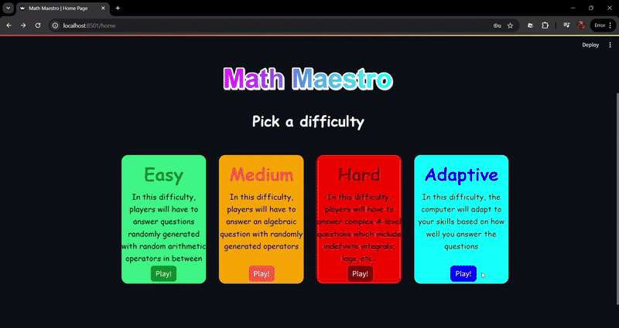

Test case 3 (Easy -> Medium):
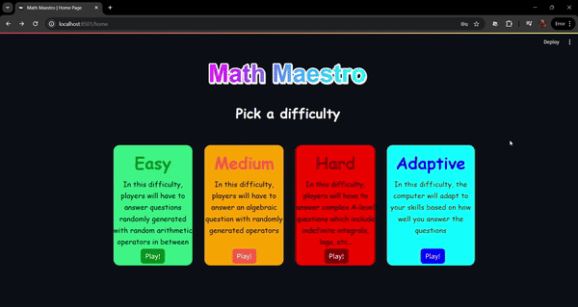

Test case 4 (Hard -> Medium):
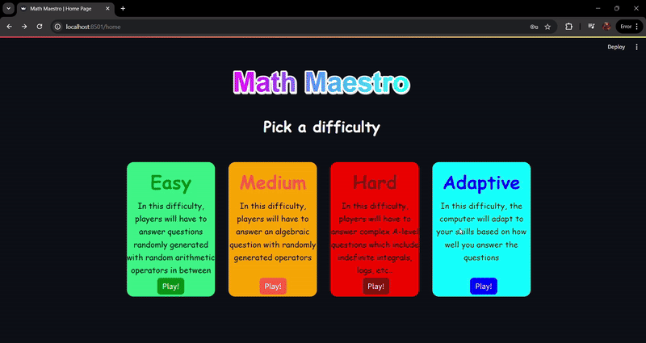

Test case 5 (Medium -> Easy):
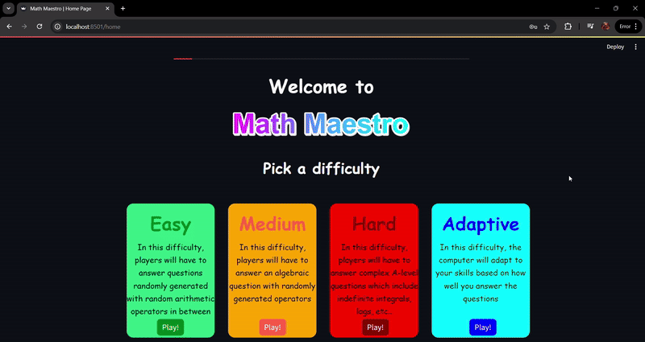

Test case 6 (Easy -> Easy):
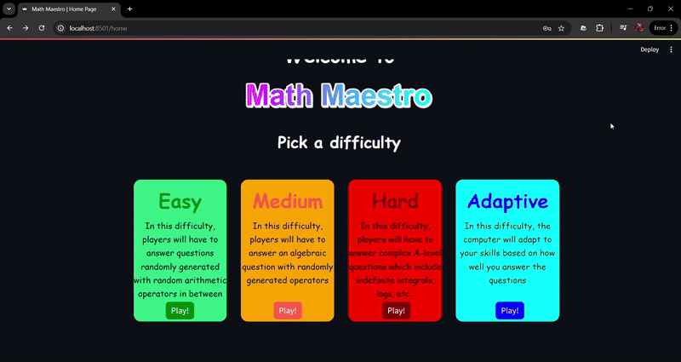

Test case 7 (Medium -> Medium):
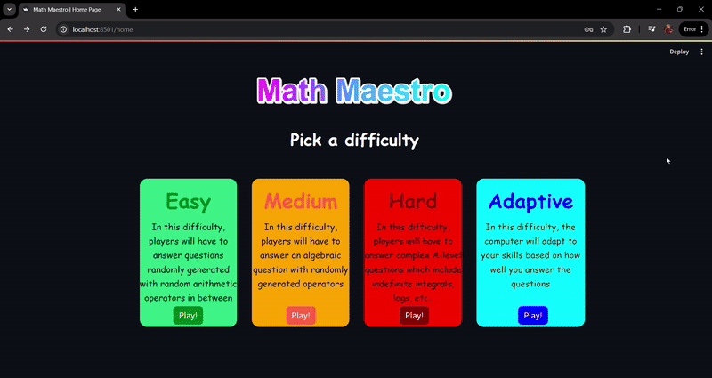

Test case 8 (Hard -> Hard):
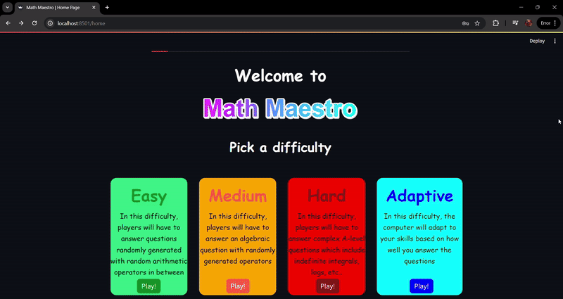

Outcome of the test: Test was successful as clearly seen in the test cases above. The difficulties were switch according to how well the user was doing.

Approach to fixing the problem: N/A
Date: 20/09/2024

What is being tested? Development of leaderboards. Currently testing if the leaderboards show the correct personal records and leaderboard records.

Details about the code:

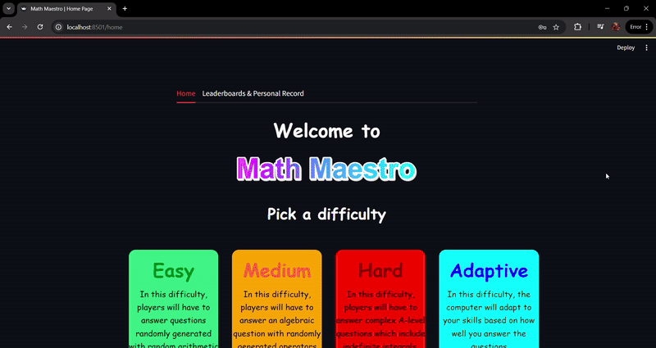

Data stored in main csv:
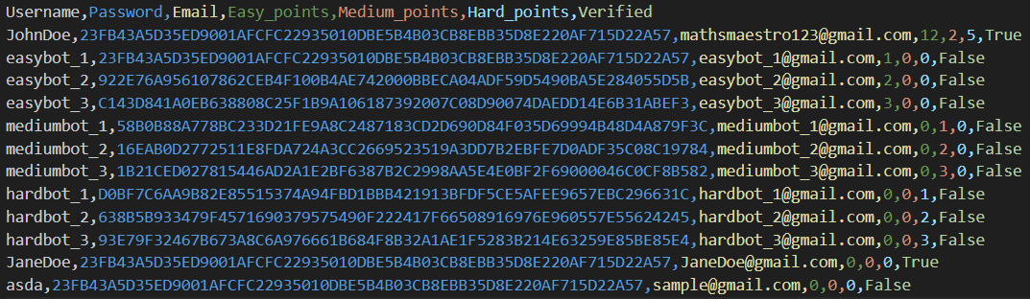

Outcome of the test: The program correctly finds the top 3 scorers for each difficulty and lets the user view their own personal record in the corresponding difficulties.

Approach to fix the problem: N/A
Date: 20/09/2024

What is being tested? Development of leaderboards. Testing to see how the leaderboards react when the user gets a score higher than their personal and the leaderboards record.

Details about the code:

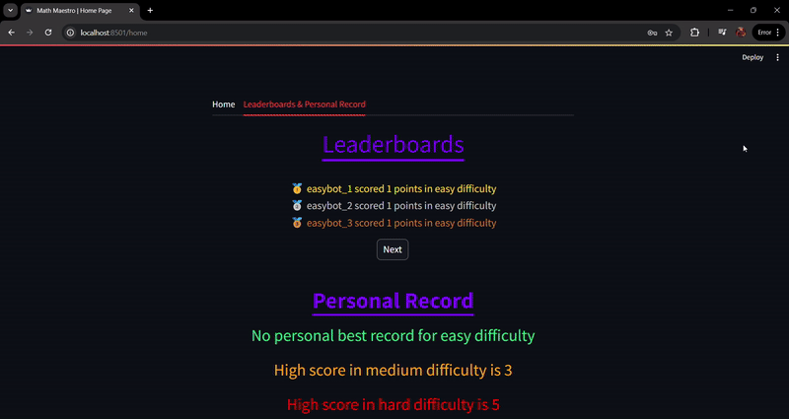

Outcome of the test: Test has been successful as the leaderboard acts accordingly when a new user beats the top scorers and their own personal record

Approach to fix the problem: N/A
Date: 21/09/2024

What is being tested? Development of leaderboards. Testing the graph that shows their user progress.

Details about the code:

Test case 1 (10+ games played with fake data):
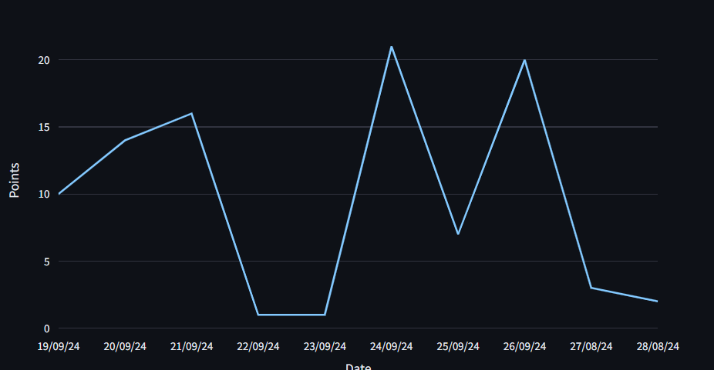
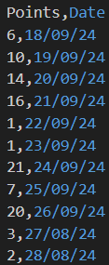

Test case 2 (Less than 10 games played):
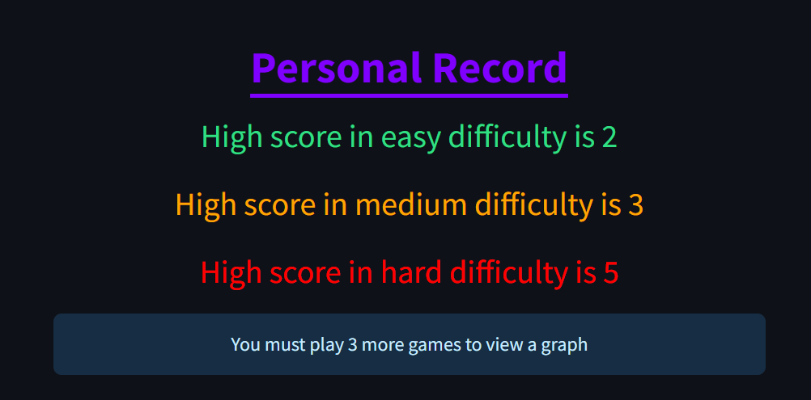
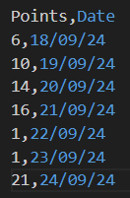

Outcome of the test: Test was the successful as the graph correctly shows the points the user scored in their previous 10 games. And if they haven’t played 10 games then the graph isn’t shown.

Approach to fix the problem: N/A
Date: 21/09/2024

What is being tested? Development of leaderboards. Testing to see how playing a new game affects the graph.

Details about the code:

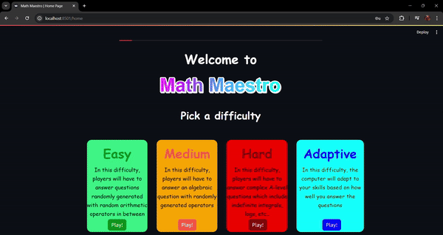

Outcome of the test: The test was successful as the graph removed the 11th previous game played to add the newest game played to the graph.

Approach to fixing the problem: N/A
Date: 22/09/2024

What is being tested? Nothing. Adding comments to the code to make it the logic of the program easier to understand

Details about the code: N/A

Outcome of the test: N/A

Approach to fix the problem: N/A

Evaluation of the solution

Beta testing
This will be tested by my classmates to check for any small errors in the program. The errors will likely be fixed in the future.
Details about the code:

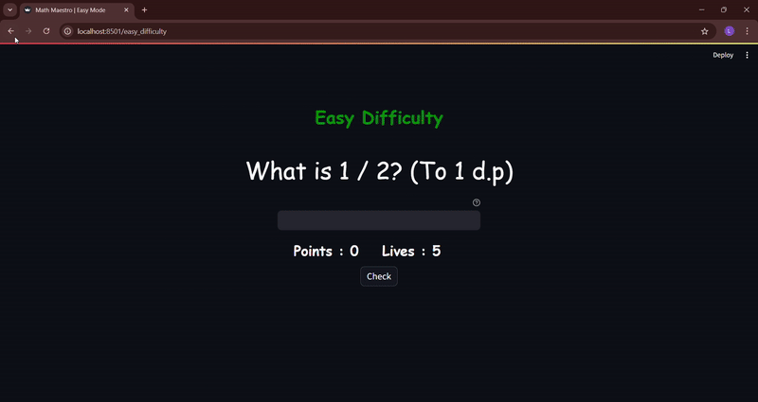
Notes: As clearly seen above, the answer should’ve been 0.3 as the answers are always rounded up to 1 decimal place. However, this problem cannot be fixed as this is due to the way python’s rounding function using the banker’s rounding rule. This means that when rounding numbers to 1 decimal place, numbers such as X.X5 will be in the midpoint. In this case, 0.25 is between 0.2 and 0.3 and using the banker’s rounding rule, 0.2 is even so the function round downs to 0.2 instead of 0.3.
Details about the code:

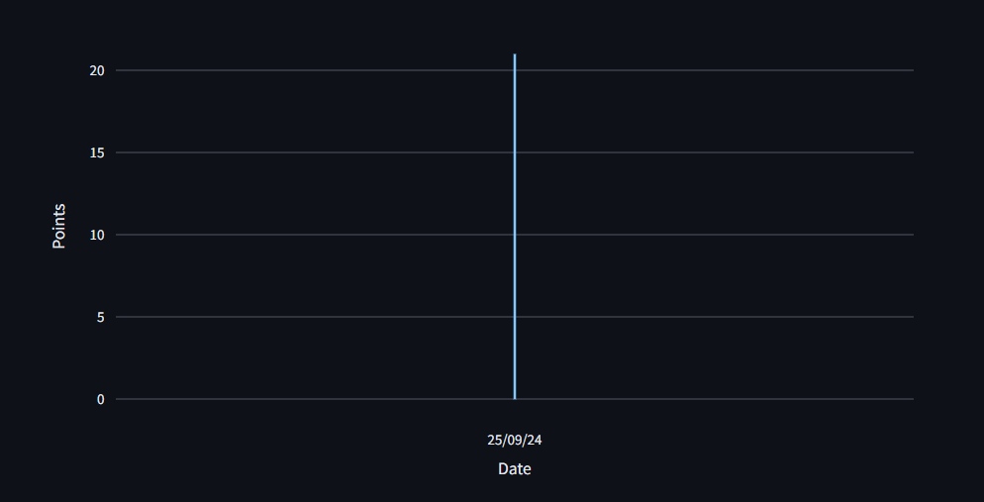

Notes: As shown above, when playing multiple games in the same day, the graph is sketched unexpectedly. This problem could be solved by using other graphical representation of data such as a bar chart.
Details about the code:

Phone view:
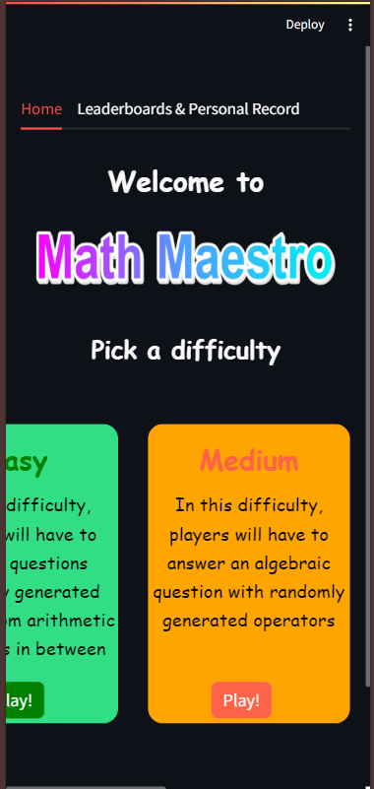

iPad view:
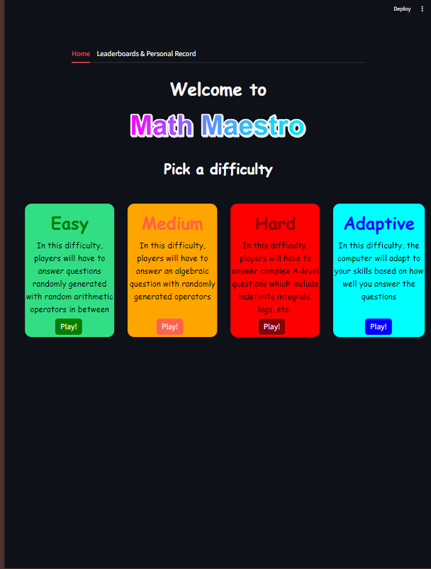

Notes: As expected, since the CSS isn’t responsive, the users may have to slide left to view the other difficulties on phone. However, when testing on iPads, the CSS seems to work perfectly fine just like desktop version.

Details about the code:

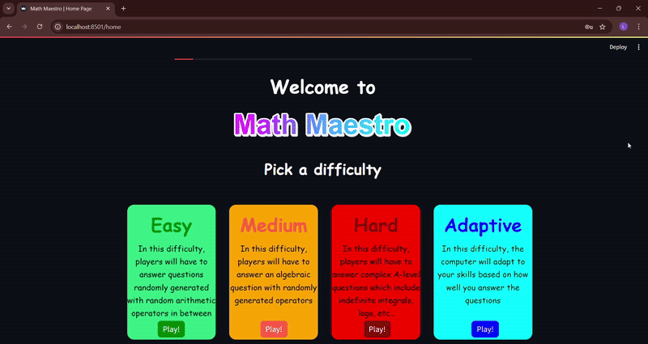

Note: As shown above, when the user enters an answer, the input bar doesn’t clear by itself, and the users must manually clear it. Although there is nothing wrong with this, it may affect the user experience negatively.

Client testing
During this phase, I will ask my client to use my program for a day as a substitute for what they would normally use. For example, when answering questions, instead of using Kahoot, they would be using my program instead and providing feedback upon it. There will be no test data for the client as the website randomly generates questions. Once the client is finished reviewing the program, they can summarize the review by filling out my feedback table. The feedback table will have multiple categories: Performance, User Experience, Clarity, Usability and Overall Rating. This will be a good way to test how the program might perform in the real world without any biases. All the scores will be out of 10, a 7 will be considered as success, a 5 will be considered as decent but can be improved to perform better and anything below will be considered a failure. Performance will be used to check how well a certain function / game-mode performs , User Experience will be used to check how smooth the overall web experience feels, Clarity will be used to check how easy it is to understand for the client what they’re supposed to solve for, Usability will be used to check how likely they will use the program over other websites and Overall Rating will be used to evaluate the program using the client’s opinion. I will consider 27/40 and above an overall success.

Client feedback
Categories | Score | Comments
Performance | 7.3/10 (Average) | N/A
Login page | 8/10 | This page works perfectly fine but on phone the website appears a bit weird
Register page | 7/10 | This page works perfectly fine but sending a 6-digit PIN to the user’s email to verify it’s them seems a bit excessive.
Hashing password | 7/10 | Although it keeps the user’s password very secure, it seems a bit excessive for a program with a small scope.
Home page | 7/10 | This page works perfectly fine but on phone, not all the difficulties may be seen at once.
Easy difficulty | 7/10 | This page works perfectly fine although it seems a bit too easy for GCSE students
Medium difficulty | 8/10 | This page works perfectly fine and can be used as training for mental maths.
Hard difficulty | 9/10 | Although initially the jump from medium to hard is large. After learning the concepts, it became a very good source of practicing the skills I learnt.
Adaptive difficulty | 8/10 | This difficulty is perfect as it incorporates all the other difficulties. However, changing the difficulty every 5 questions seem a bit long considering that we only have 7 lives.
Leaderboards page | 5/10 | I don’t really like the fact that you need to play 10 games to see the graph as it can be vital for the user to know how well they have been doing. Additionally, the graph appears weirdly when playing more than 1 game on the same day.
User Experience | 6/10 | Navigating through the website feels very smooth and the colour choices for the website are nice. However, if a user accidentally refreshes the website, they are forced to log in again. Although this can prevent unforeseen errors, this could be very disrupting for other users. Additionally, as said before, the website looks weird on phone.
Clarity | 9/10 | It was very easy for me to know what I was supposed to solve for. Especially in hard difficulty where the questions were presented neatly. Although, it took me some time to understand what the differentiation question was asking me to do.
Usability | 8/10 | The first two difficulties can be used to train mental math skills and hard difficulty can be used to practice new A-level maths skills. Adaptive difficulty is also nice because it incorporates all the difficulties. However, once I become proficient enough, I will most likely use other websites. This is since the website does not include all of A-level pure maths content.
Overall Rating | 30.3/40

Conclusion
Referring to the feedback provided by the client, the program scored a 30.3/40. This means that the program was a success for the client. However, some individual sections may need improving on as they scored quite low (e.g. Leaderboards page). Although the solution was a success, the program is not perfect and may experience some unexpected errors. However, my main goal of it being a website that could potentially be used over other existing solutions has been achieved.

Success of the solution
Requirements
- Login page
This section was given an 8/10 by the client. This means that the page works perfectly fine, but the mobile view of the website may appear clunky. This is because my CSS skills aren’t proficient enough to scale the web designs proportionate to the user’s device.
- Register page
This section was given a 7/10 by the client. I understand that the client may think that sending a 6-digit PIN is a bit excessive but, this function was created with the idea that if my website was attacked by millions of bots without any verification, the csv files created would grow exponentially to store all their data. This means that the program will likely run slower as it would take the program longer to find and read specific data from the csv files.
- Hashing password
This section was given a 7/10 by the client. Considering the scope of the program, it makes sense why the client thinks this feature may be a bit extra. However, hashing a password is a good practice to keep the user’s data secure.
- Easy difficulty
This section was given a 7/10 by the client. I agree with the client that this difficulty might be too easy for some users. However, this difficulty was created to be answered without the use of a calculator.
- Medium difficulty
This section was given an 8/10 by the client. This difficulty is perfect for users who may want to improve their mental maths skills.
- Hard difficulty
This section was given a 9/10 by the client. I agree with the client that this difficulty is an immense jump from medium difficulty, but I created this difficulty assuming that the users learnt a bit of A-level pure maths from other sources.
- Adaptive difficulty
This section was given an 8/10 by the client. However, I think changing the difficulty every 5 questions is perfectly fine as it gives the users enough time to experience each difficulty.
- Leaderboards page
This section was given a 5/10 by the client. I made the graph show only the 10 previous games as it would look nicer as opposed to previous 8 or lower games. Furthermore, it gives the users more time to improve their skills in each game mode and they can see how much they’ve improved by viewing the graph. However, the graph appearing weirdly when playing multiple games in a single day is an error I will try to fix in the future.

Success criteria
- User data is saved correctly, and a code is sent to their email address
This criterion has been successfully met, although sending a code to the user’s email address seems a bit redundant in the client’s opinion.
- Program correctly generates random questions and have the correct answers for them
This criterion has been successfully met, although as shown in beta testing, it will incorrectly produce answers for some questions.
- Program does not crash when user refreshes or presses the back button on the browser
This criterion has been successfully met, although the client seems to find this feature a bit annoying when accidentally refreshing.
- Program flags an error when an incorrect data type is entered as an answer
This criterion has been successfully met.
- Will the users be able to know what they’re supposed to solve for?
This criterion has been successfully met, as suggested in the client’s feedback where it was given a 9/10. Albeit the differentiation question could be presented clearer.
- Is this solution better than existing solutions?
This criterion has been partially met, the client mentioned that for purely practicing their maths skills, they would consider my solution over other existing solutions. However, once the client has been proficient enough, they will switch to other solutions to further develop their skills.

Maintenance and Development
Maintenance
My solution is very easy to use as all the relevant code and resources are published on my GitHub repository. Furthermore, I have also added relevant instructions to my README.md as shown below:
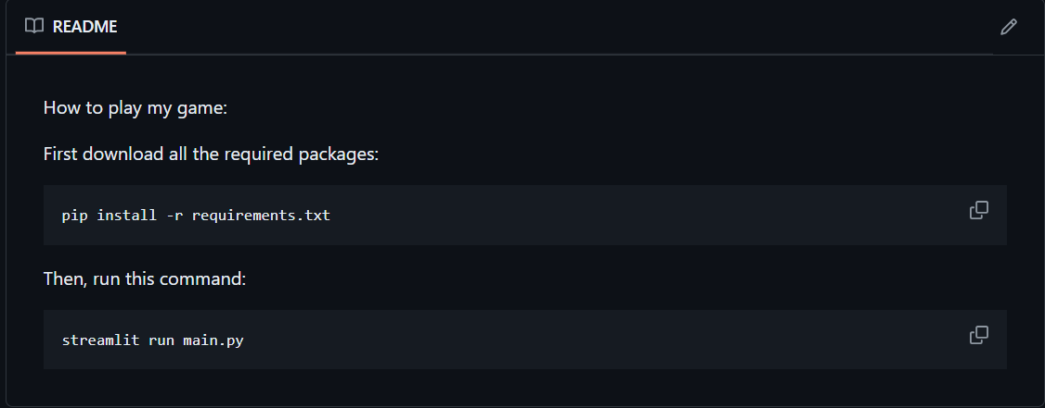
The solution should be downloaded as a ZIP file then, the users must extract the ZIP file. After this, assuming they have Python and VS Code install, they should copy the instructions in the README file into the terminal.

Further development
If I had sufficient time, the first thing I would do is to learn more CSS so I can implement better web designs and make it responsive. Next, I would also like the “Forgot password?” page to be within one page instead of two pages. This would make the user experience much smoother. Furthermore, adding a “Re-enter password” section during the register page would be beneficial as it allows the users to make sure what they want their password to be. Additionally, I would like to improve the function that checks if an email address is valid as some email addresses with fake top-level domain names may pass through. Moreover, adding more difficulties would be better for the users for example, a difficulty that includes indefinite integrals and derivatives. Finally, I think using a database like MySQL to store user data could be better than using a csv file. However, I wasn’t sure on how to make the database accessible to everyone instead of having it stored locally on my computer.

Complete code for my solution
Code directory structure:
📁 a_level_project
└── 📁__pycache__
└── 📄 AdaptiveQuestions.cpython-311.pyc
└── 📄 EquationSolver.cpython-311.pyc
└── 📄 SecurePassword.cpython-311.pyc
└── 📁.streamlit
└── 📄 config.toml
└── 📁.vscode
└── 📁main_data
└── 📄 data.csv
└── 📁pages
└── 📄 adaptive_difficulty.py
└── 📄 easy_difficulty.py
└── 📄 error_page.py
└── 📄 forgot_page.py
└── 📄 game_over.py
└── 📄 get_username.py
└── 📄 hard_difficulty.py
└── 📄 home.py
└── 📄 login_page.py
└── 📄 medium_difficulty.py
└── 📄 verify.py
└── 📁static
└── 📄 difficulty.html
└── 🖼️ game_logo.png
└── 🖼️ header.png
└── 📄 styles.css
└── 📁user_data
└── 📄 easybot_1.csv
└── 📄 easybot_2.csv
└── 📄 easybot_3.csv
└── 📄 hardbot_1.csv
└── 📄 hardbot_2.csv
└── 📄 hardbot_3.csv
└── 📄 JohnDoe.csv
└── 📄 mediumbot_1.csv
└── 📄 mediumbot_2.csv
└── 📄 mediumbot_3.csv
└── 📄.gitignore
└── 📄 AdaptiveQuestions.py
└── 📄 EquationSolver.py
└── 📄 main.py
└── 📄 README.md
└── 📄 requirements.txt
└── 📄 SecurePassword.py

Code for adaptive_difficulty.py:
import streamlit as st
import pandas as pd
import time
import datetime
from AdaptiveQuestions import AdaptiveQuestions
from streamlit_extras.switch_page_button import switch_page

# function to check if a variable is a type of the parameter
# Has been modified to accept negative values
def check_type(answer, type):
if str(answer).count("-") == 1:
answer = answer[1:]
try:
type(answer)
return True
except ValueError:
return False

# function that shows the visual effects of "+1" or "-1"
# temporarily for lives/points
def animation(before_animation, after_animation, box_name, duration=1):
box_name.write(f"{before_animation}", unsafe_allow_html=True)
time.sleep(duration)
box_name.write(f"{after_animation}", unsafe_allow_html=True)

def generate_random_question(avg_score, arr=[], diff=None):
# Initially, the diff is None because the class creates
# the initial difficulty by taking the average of the
# user's past scores
instance = AdaptiveQuestions(avg_score, arr, diff)
question, answer, one_dp, diff = instance.generate_initial_question()
return question, answer, one_dp, diff

if "user" not in st.session_state:
switch_page("error page")

# This block of code is used to ensure that if the user attempts
# to go back to the home page whilst in a game, it will handle
# things accordingly
if "playing" in st.session_state and not (st.session_state["playing"]):
for key in st.session_state.keys():
if key != "user":
del st.session_state[key]

if "question" not in st.session_state:
df = pd.read_csv(f"user_data/{st.session_state['user']}.csv")
try:
avg_score = sum(df["Points"]) / len(df["Points"])
except ZeroDivisionError:
avg_score = 0
question, answer, one_dp, diff = generate_random_question(avg_score)
st.session_state["question"], st.session_state["ans"] = question, answer
st.session_state["one_dp"], st.session_state["stored_points"] = one_dp, 0
st.session_state["points"], st.session_state["lives"] = 0, 7
st.session_state["array"], st.session_state["asked_questions"] = [], 0
st.session_state["difficulty"] = diff

st.set_page_config(page_title="Math Maestro | Adaptive Mode")

# custom styling
with open("static/styles.css") as f:
st.markdown(f"<style>{f.read()}</style>", unsafe_allow_html=True)

df = pd.read_csv("main_data/data.csv")
st.markdown(
"""
<div id = 'sub-header'>
<h2>
<span style='color:blue;'>
Adaptive Difficulty
</span>
</h2>
</div>""",
unsafe_allow_html=True,
)
# name of all the keys added in the session
keys = ["question", "ans", "one_dp", "points", "lives", "array"]
st.markdown('<span id="question"></span>', unsafe_allow_html=True)
question_box = st.empty()
if st.session_state["difficulty"] != "Hard":
question_box.write(f"<p>{st.session_state['question']}</p>", unsafe_allow_html=True)
else:
question_box.latex(f"{st.session_state['question']}")
padding_left, input, padding_right = st.columns([1, 3, 1])
if st.session_state["difficulty"] == "Easy":
input_msg = "Find the answer"
if st.session_state["difficulty"] == "Medium" and st.session_state["one_dp"]:
input_msg = "Find y to 1 d.p"
elif st.session_state["difficulty"] == "Medium":
input_msg = "Find y"
if st.session_state["difficulty"] == "Hard" and st.session_state["one_dp"]:
input_msg = "Find x to 1.dp"
elif st.session_state["difficulty"] == "Hard":
input_msg = "Find x"
user_ans = input.text_input(
f"{input_msg}",
help="Get as many answers correct as possible before you run out of lives",
)
info_box = st.empty()
info_box.write(
f"""
<div id = 'info'>
<h3>Points : {st.session_state['points']}</h3>
<h3>Lives : {st.session_state['lives']}</h3>
</div>""",
unsafe_allow_html=True,
)
st.markdown('<span id="check-button"></span>', unsafe_allow_html=True)
button = st.button("Check")
st.markdown('<span id="info-message"></span>', unsafe_allow_html=True)
padding_left, invalid_format, padding_right = st.columns([1, 3, 1])
st.markdown('<span id="error-message"></span>', unsafe_allow_html=True)
padding_left, incorrect_answer, padding_right = st.columns([1, 3, 1])
if button:
if check_type(user_ans, int) or check_type(user_ans, float):
st.markdown(
"""
<style>
.element-container:has(#check-button) + div button{
display:none;
}
</style>""",
unsafe_allow_html=True,
)
# checks if the user's answer is correct
if round(float(user_ans), 1) == round(float(st.session_state["ans"]), 1):
st.session_state["array"].append(1)
st.session_state["asked_questions"] += 1
st.session_state["points"] += 1
before_msg = f"""
<div id = 'info'>
<h3 style='color:green;'>+1</h3>
<h3>Lives : {st.session_state['lives']}</h3>
</div>"""
after_msg = f"""
<div id = 'info'>
<h3>Points : {st.session_state['points']}</h3>
<h3>Lives : {st.session_state['lives']}</h3>
</div>"""
animation(before_msg, after_msg, info_box)
else:
incorrect_answer.error(
f"Incorrect! The answer was {st.session_state['ans']}"
)
st.session_state["array"].append(0)
st.session_state["asked_questions"] += 1
st.session_state["lives"] -= 1
if st.session_state["lives"] == 0:
st.session_state["difficulty"] = "Adaptive"
# Adds the point to their personal record along with current
# date and time
with open(f"user_data/{st.session_state['user']}.csv", "a") as f:
current_time = datetime.datetime.now()
format_time = current_time.strftime("%d/%m/%y")
f.write("\n")
f.write(f"{st.session_state['points']},{format_time}")
for key in keys:
# deletes all the added session keys
del st.session_state[key]
switch_page("game over")
before_msg = f"""
<div id='info'>
<h3>Points : {st.session_state['points']}</h3>
<h3 style='color:red;'>-1</h3>
</div>"""
after_msg = f"""
<div id = 'info'>
<h3>Points : {st.session_state['points']}</h3>
<h3>Lives : {st.session_state['lives']}</h3>
</div>"""
animation(before_msg, after_msg, info_box)
st.markdown(
"""
<style>
.element-container:has(#check-button) + div button{
display:flex;
}
</style>""",
unsafe_allow_html=True,
)
# generates a new random question
if len(st.session_state["array"]) == 5:
question, answer, one_dp, diff = generate_random_question(
-1, st.session_state["array"], None
)
st.session_state["question"] = question
st.session_state["ans"] = answer
st.session_state["one_dp"] = one_dp
st.session_state["difficulty"] = diff
st.session_state["array"] = []
else:
question, answer, one_dp, diff = generate_random_question(
-1, st.session_state["array"], st.session_state["difficulty"]
)
st.session_state["question"] = question
st.session_state["ans"] = answer
st.session_state["one_dp"] = one_dp
# updating the box to display the newly generated question
if st.session_state["difficulty"] != "Hard":
question_box.write(
f"<p>{st.session_state['question']}</p>", unsafe_allow_html=True
)
else:
question_box.latex(f"{st.session_state['question']}")
# rerunning the script for the visual effects
st.rerun()

# else, an error message is flagged
else:
invalid_format.info("Invalid format")

Code for easy_difficulty.py:
import streamlit as st
import random
import time
import pandas as pd
import datetime
from streamlit_extras.switch_page_button import switch_page

# function to check if a variable is a type of the parameter
def check_type(answer, type):
try:
type(answer)
return True
except ValueError:
return False

def generate_random_question():
random_op = random.choice(["+", "-", "*", "/"])
if random_op in ["/", "*"]:
num1, num2 = random.randint(1, 10), random.randint(1, 10)
else:
num1, num2 = random.randint(1, 100), random.randint(1, 100)
answer = round(eval(f"{num1} {random_op} {num2}"), 1)
if random_op == "/":
return f"What is {num1} {random_op} {num2}? (To 1 d.p)", answer
else:
return f"What is {num1} {random_op} {num2}?", answer

# function that shows the visual effects of "+1" or "-1"
# temporarily for lives/points
def animation(before_animation, after_animation, box_name, duration=1):
box_name.write(f"{before_animation}", unsafe_allow_html=True)
time.sleep(duration)
box_name.write(f"{after_animation}", unsafe_allow_html=True)

if "user" not in st.session_state:
switch_page("error page")

# This block of code is used to ensure that if the user attempts
# to go back to the home page whilst in a game, it will handle
# things accordingly
if "playing" in st.session_state and not (st.session_state["playing"]):
for key in st.session_state.keys():
if key != "user":
del st.session_state[key]

st.set_page_config(page_title="Math Maestro | Easy Mode")

# custom styling
with open("static/styles.css") as f:
st.markdown(f"<style>{f.read()}</style>", unsafe_allow_html=True)

df = pd.read_csv("main_data/data.csv")
st.markdown(
"""
<div id = 'sub-header'>
<h2>
<span style='color:green;'>
Easy Difficulty
</span>
</h2>
</div>""",
unsafe_allow_html=True,
)
# name of all the keys added in the session
keys = ["question", "ans", "points", "lives"]

# storing user data and questions in the session
if "question" not in st.session_state:
st.session_state["question"], st.session_state["ans"] = generate_random_question()
st.session_state["points"], st.session_state["lives"] = 0, 5
st.session_state["difficulty"], st.session_state["asked_questions"] = "Easy", 0
st.session_state["stored_points"] = 0

st.markdown('<span id="question"></span>', unsafe_allow_html=True)
question_box = st.empty()
question_box.write(f"<p>{st.session_state['question']}</p>", unsafe_allow_html=True)
padding_left, input, padding_right = st.columns([1, 3, 1])
user_ans = input.text_input(
" ", help="Get as many answers correct as possible before you run out of lives"
)
info_box = st.empty()
info_box.write(
f"""
<div id = 'info'>
<h3>Points : {st.session_state['points']}</h3>
<h3>Lives : {st.session_state['lives']}</h3>
</div>""",
unsafe_allow_html=True,
)
st.markdown('<span id="check-button"></span>', unsafe_allow_html=True)
button = st.button("Check")
st.markdown('<span id="info-message"></span>', unsafe_allow_html=True)
padding_left, invalid_format, padding_right = st.columns([1, 3, 1])
st.markdown('<span id="error-message"></span>', unsafe_allow_html=True)
padding_left, incorrect_answer, padding_right = st.columns([1, 3, 1])
if button:
# checks if the user input is an int or float
if check_type(user_ans, int) or check_type(user_ans, float):
st.markdown(
"""
<style>
.element-container:has(#check-button) + div button{
display:none;
}
</style>""",
unsafe_allow_html=True,
)
# checks if the user's answer is correct
if round(float(user_ans), 1) == round(float(st.session_state["ans"]), 1):
st.session_state["asked_questions"] += 1
st.session_state["points"] += 1
before_msg = f"""
<div id = 'info'>
<h3 style='color:green;'>+1</h3>
<h3>Lives : {st.session_state['lives']}</h3>
</div>"""
after_msg = f"""
<div id = 'info'>
<h3>Points : {st.session_state['points']}</h3>
<h3>Lives : {st.session_state['lives']}</h3>
</div>"""
animation(before_msg, after_msg, info_box)
else:
incorrect_answer.error(
f"Incorrect! The answer was {st.session_state['ans']}"
)
st.session_state["asked_questions"] += 1
st.session_state["lives"] -= 1
if st.session_state["lives"] == 0:
get_points = df.loc[
df["Username"] == st.session_state["user"], "Easy_points"
]
for i in get_points:
if i > st.session_state["points"]:
change_score = False
else:
change_score = True

if change_score:
# updates the user's Easy_points score
df.loc[
df["Username"] == st.session_state["user"], "Easy_points"
] = st.session_state["points"]
df.to_csv("main_data/data.csv", index=False)

# Adds the point to their personal record along with current
# date and time
with open(f"user_data/{st.session_state['user']}.csv", "a") as f:
current_time = datetime.datetime.now()
format_time = current_time.strftime("%d/%m/%y")
f.write("\n")
f.write(f"{st.session_state['points']},{format_time}")
st.session_state["stored_points"] = st.session_state["points"]
for key in keys:
# deletes all the added session keys
del st.session_state[key]
switch_page("game over")
before_msg = f"""
<div id='info'>
<h3>Points : {st.session_state['points']}</h3>
<h3 style='color:red;'>-1</h3>
</div>"""
after_msg = f"""
<div id = 'info'>
<h3>Points : {st.session_state['points']}</h3>
<h3>Lives : {st.session_state['lives']}</h3>
</div>"""
animation(before_msg, after_msg, info_box)
st.markdown(
"""
<style>
.element-container:has(#check-button) + div button{
display:flex;
}
</style>""",
unsafe_allow_html=True,
)
# generates a new random question
st.session_state["question"], st.session_state["ans"] = (
generate_random_question()
)
# updating the box to display the newly generated question
question_box.write(
f"<p>{st.session_state['question']}</p>", unsafe_allow_html=True
)
# rerunning the script for the visual effects
st.rerun()

# else, an error message is flagged
else:
invalid_format.info("Invalid format")

Code for error_page.py:
import streamlit as st

st.set_page_config(page_title="Math Maestro | 404 error page")

# custom styling
with open("static/styles.css") as f:
st.markdown(f"<style>{f.read()}</style>", unsafe_allow_html=True)

st.write(
"<h1>401 Error , You must be logged in </h1>",
unsafe_allow_html=True,
)

st.write(
"<div id = 'header_error'><h4>Click <a href='http://localhost:8501/login_page' target='_self'> here </a> to be redirected to the main page </h4></div>",
unsafe_allow_html=True,
)

Code for forgot_page.py:
import streamlit as st
import random
import pandas as pd
import ssl
import smtplib
from SecurePassword import SecurePassword
from email.message import EmailMessage
from streamlit_extras.switch_page_button import switch_page

st.set_page_config(page_title="Math Maestro | Forgot Page")

# custom styling
with open("static/styles.css") as f:
st.markdown(f"<style>{f.read()}</style>", unsafe_allow_html=True)

if "temp_user" not in st.session_state:
switch_page("error page")

df = pd.read_csv("main_data/data.csv")

if "verification_code" not in st.session_state:
# This entire block of code makes an email
# along with a random 6-digit PIN sent
# to the user's registered email address
email_sender = "mathsmaestro123@gmail.com"
email_password = "mnwg homw fgap fika"
get_email = df.loc[df["Username"] == f"{st.session_state['temp_user']}", "Email"]
email_receiver = f"{get_email.values[0]}"
random_code = "".join([str(random.randint(0, 9)) for i in range(6)])

subject = "Maths Maestro Verification Code"
body = f"""
Hello,

This is your 6-digit verification code:
{random_code}
Make sure to not let anyone else know this code

Sincerely,
Maths Maestro
"""
em = EmailMessage()
em["From"] = email_sender
em["To"] = email_receiver
em["Subject"] = subject
em.set_content(body)

context = ssl.create_default_context()

with smtplib.SMTP_SSL("smtp.gmail.com", 465, context=context) as smtp:
smtp.login(email_sender, email_password)
smtp.sendmail(email_sender, email_receiver, em.as_string())
st.session_state["verification_code"] = random_code

def is_password_valid(password):

def has_special_chars(word):
return not (all(i.isalnum() for i in word))

def has_upper_chars(word):
return any(i.isupper() for i in word)

def has_lower_chars(word):
return any(i.islower() for i in word)

error_msg = ""
if password:
if len(password) < 8:
error_msg = "Password is must be at least 8 characters long"
return (False, error_msg)
elif has_special_chars(password) == False:
error_msg = "Password must have a special character"
return (False, error_msg)
elif has_lower_chars(password) == False:
error_msg = "Password must have at least 1 lowercase letter"
return (False, error_msg)
elif has_upper_chars(password) == False:
error_msg = "Password must have at least 1 uppercase letter"
return (False, error_msg)
else:
return (True, error_msg)
else:
return ("", error_msg)

st.header("Verify it's you")
new_password = st.text_input(
"New password",
type="password",
placeholder="Enter a new password",
max_chars=55,
)
verify_code = st.text_input(
"Enter the verification code sent to your email",
max_chars=6,
)

submit = st.button("Submit", type="primary")
if submit:
pass_result, pass_error = is_password_valid(new_password)
if verify_code == st.session_state["verification_code"] and pass_result:
st.session_state["user"] = st.session_state["temp_user"]
del st.session_state["temp_user"]
instance = SecurePassword(new_password)
# Updating the old password with the new hashed password
df.loc[df["Username"] == f"{st.session_state['user']}", "Password"] = (
instance.secure()
)
df.to_csv("main_data/data.csv", index=False)
switch_page("home")
elif verify_code != st.session_state["verification_code"]:
st.error("Incorrect PIN entered , please try again")
else:
st.error(f"{pass_error}")

Code for game_over.py:
import streamlit as st
import plotly.express as px
from streamlit_extras.switch_page_button import switch_page

st.set_page_config(page_title="Math Maestro | Game Over")
# custom styling
with open("static/styles.css") as f:
st.markdown(f"<style>{f.read()}</style>", unsafe_allow_html=True)

if "user" not in st.session_state:
switch_page("error page")

st.markdown(
"""
<div id='game-over-header'>
<h1>GAME OVER</h1>
</div>""",
unsafe_allow_html=True,
)
df = {
"Answers": ["Incorrect", "Correct"],
"Points": [
st.session_state["asked_questions"] - st.session_state["stored_points"],
st.session_state["stored_points"],
],
}
figure = px.pie(
data_frame=df,
names="Answers",
values="Points",
color_discrete_sequence=["Red", "Green"],
title="Game overview",
)
st.plotly_chart(figure)
st.write(
f"""
<div id = 'game-stats'>
<h3>
You scored {st.session_state['stored_points']} points
in {st.session_state['difficulty']} difficulty
</h3>
</div>""",
unsafe_allow_html=True,
)
st.markdown("<span id='retry-btn'></span>", unsafe_allow_html=True)
retry = st.button("Retry")
if retry:
switch_page("home")

Code for get_username.py:
import streamlit as st
import pandas as pd
from streamlit_extras.switch_page_button import switch_page

st.set_page_config(page_title="Math Maestro | Get Username Page")

# custom styling
with open("static/styles.css") as f:
st.markdown(f"<style>{f.read()}</style>", unsafe_allow_html=True)

if "user" in st.session_state:
switch_page("error page")

def does_username_exist(username):
if username:
return any(i == username for i in df["Username"])
else:
return ""

st.header("Enter your username")
df = pd.read_csv("main_data/data.csv")
username = st.text_input(
"Username", max_chars=20, placeholder="Enter a unique username"
)
submit = st.button("Submit", type="primary")
if submit:
if does_username_exist(username):
st.session_state["temp_user"] = username
switch_page("forgot page")
else:
st.error("Username does not exist")

Code for hard_difficulty.py:
import random
import streamlit as st
import pandas as pd
import time
import datetime
import math
from streamlit_extras.switch_page_button import switch_page

# function to check if a variable is a type of the parameter
# Has been modified to accept negative values
def check_type(answer, type):
if str(answer).count("-") == 1:
answer = answer[1:]
try:
type(answer)
return True
except ValueError:
return False

def integrate():
upper_interval, lower_interval, bigger_power, lower_power = (
random.randint(1, 10),
-random.randint(1, 10),
random.randint(6, 9),
random.randint(2, 5),
)
latex_equation = r"\int_{lower}^{upper} (x^{pow1} + x^{pow2}) dx"
equation = (
latex_equation.replace("lower", f"{lower_interval}")
.replace("upper", f"{upper_interval}")
.replace("pow1", f"{bigger_power}")
.replace("pow2", f"{lower_power}")
)
bigger_power += 1
lower_power += 1
upper_antiderivative = (upper_interval**bigger_power) / bigger_power + (
upper_interval**lower_power
) / lower_power
lower_antiderivative = (lower_interval**bigger_power) / bigger_power + (
lower_interval**lower_power
) / lower_power
answer = upper_antiderivative - lower_antiderivative
return equation, round(answer, 1)

def differentiate():
value_x, bigger_power, lower_power = (
random.randint(1, 10),
random.randint(6, 9),
random.randint(2, 5),
)
latex_equation = r"\frac {dy}{dx} \, (x^{pow1} + x^{pow2}) \, \vert_{\,x={val}}"
equation = (
latex_equation.replace("pow1", f"{bigger_power}")
.replace("pow2", f"{lower_power}")
.replace("val", f"{value_x}")
)
upper_derivative = bigger_power * (value_x) ** (bigger_power - 1)
lower_derivative = lower_power * (value_x) ** (lower_power - 1)
answer = upper_derivative + lower_derivative
return equation, round(answer, 1)

def logarithmics():
base, exponent = random.randint(2, 9), random.randint(0, 20)
latex_equation = r"\log_base (x) = exponent"
equation = latex_equation.replace("base", f"{base}").replace(
"exponent", f"{exponent}"
)

answer = base**exponent
return equation, round(answer, 1)

def exponents():
base, result = random.randint(2, 10), round(random.uniform(1, 10), 1)
latex_equation = r"base^x = ans"
equation = latex_equation.replace("base", f"{base}").replace("ans", f"{result}")
log_result = math.log(result)
log_base = math.log(base)
answer = log_result / log_base
return equation, round(answer, 1)

# function that shows the visual effects of "+1" or "-1"
# temporarily for lives/points
def animation(before_animation, after_animation, box_name, duration=1):
box_name.write(f"{before_animation}", unsafe_allow_html=True)
time.sleep(duration)
box_name.write(f"{after_animation}", unsafe_allow_html=True)

if "user" not in st.session_state:
switch_page("error page")

# This block of code is used to ensure that if the user attempts
# to go back to the home page whilst in a game, it will handle
# things accordingly
if "playing" in st.session_state and not (st.session_state["playing"]):
for key in st.session_state.keys():
if key != "user":
del st.session_state[key]

st.set_page_config(page_title="Math Maestro | Hard Mode")

# custom styling
with open("static/styles.css") as f:
st.markdown(f"<style>{f.read()}</style>", unsafe_allow_html=True)

df = pd.read_csv("main_data/data.csv")
st.markdown(
"""
<div id = 'sub-header'>
<h2>
<span style='color:red;'>
Hard Difficulty
</span>
</h2>
</div>""",
unsafe_allow_html=True,
)
# name of all the keys added in the session
keys = ["question", "ans", "points", "lives"]

func_dict = {
"integrate": integrate(),
"differentiate": differentiate(),
"logs": logarithmics(),
"powers": exponents(),
}

# storing user data and questions in the session
if "question" not in st.session_state:
random_key = random.choice(list(func_dict.keys()))
equation, answer = func_dict.get(random_key)
st.session_state["question"], st.session_state["ans"] = equation, answer
st.session_state["points"], st.session_state["lives"] = 0, 3
st.session_state["difficulty"], st.session_state["asked_questions"] = "Hard", 0
st.session_state["stored_points"] = 0

question_box = st.empty()
question_box.latex(f"{st.session_state['question']}")
padding_left, input, padding_right = st.columns([1, 3, 1])
user_ans = input.text_input(
f"Find x to 1.dp",
help="Get as many answers correct as possible before you run out of lives",
)
info_box = st.empty()
info_box.write(
f"""
<div id = 'info'>
<h3>Points : {st.session_state['points']}</h3>
<h3>Lives : {st.session_state['lives']}</h3>
</div>""",
unsafe_allow_html=True,
)
st.markdown('<span id="check-button"></span>', unsafe_allow_html=True)
button = st.button("Check")
st.markdown('<span id="info-message"></span>', unsafe_allow_html=True)
padding_left, invalid_format, padding_right = st.columns([1, 3, 1])
st.markdown('<span id="error-message"></span>', unsafe_allow_html=True)
padding_left, incorrect_answer, padding_right = st.columns([1, 3, 1])
if button:
if check_type(user_ans, int) or check_type(user_ans, float):
st.markdown(
"""
<style>
.element-container:has(#check-button) + div button{
display:none;
}
</style>""",
unsafe_allow_html=True,
)
# checks if the user's answer is correct
if round(float(user_ans), 1) == round(float(st.session_state["ans"]), 1):
st.session_state["asked_questions"] += 1
st.session_state["points"] += 1
before_msg = f"""
<div id = 'info'>
<h3 style='color:green;'>+1</h3>
<h3>Lives : {st.session_state['lives']}</h3>
</div>"""
after_msg = f"""
<div id = 'info'>
<h3>Points : {st.session_state['points']}</h3>
<h3>Lives : {st.session_state['lives']}</h3>
</div>"""
animation(before_msg, after_msg, info_box)
else:
incorrect_answer.error(
f"Incorrect! The answer was {st.session_state['ans']}"
)
st.session_state["asked_questions"] += 1
st.session_state["lives"] -= 1
if st.session_state["lives"] == 0:
get_points = df.loc[
df["Username"] == st.session_state["user"], "Hard_points"
]
for i in get_points:
if i > st.session_state["points"]:
change_score = False
else:
change_score = True

if change_score:
# updates the user's Hard_points score
df.loc[
df["Username"] == st.session_state["user"], "Hard_points"
] = st.session_state["points"]
df.to_csv("main_data/data.csv", index=False)
st.session_state["stored_points"] = st.session_state["points"]
# Adds the point to their personal record along with current
# date and time
with open(f"user_data/{st.session_state['user']}.csv", "a") as f:
current_time = datetime.datetime.now()
format_time = current_time.strftime("%d/%m/%y")
f.write("\n")
f.write(f"{st.session_state['points']},{format_time}")
for key in keys:
# deletes all the added session keys
del st.session_state[key]
switch_page("game over")
before_msg = f"""
<div id='info'>
<h3>Points : {st.session_state['points']}</h3>
<h3 style='color:red;'>-1</h3>
</div>"""
after_msg = f"""
<div id = 'info'>
<h3>Points : {st.session_state['points']}</h3>
<h3>Lives : {st.session_state['lives']}</h3>
</div>"""
animation(before_msg, after_msg, info_box)
st.markdown(
"""
<style>
.element-container:has(#check-button) + div button{
display:flex;
}
</style>""",
unsafe_allow_html=True,
)
# generates a new random question
random_key = random.choice(list(func_dict.keys()))
equation, answer = func_dict.get(random_key)
st.session_state["question"] = equation
st.session_state["ans"] = answer
# updating the box to display the newly generated question
question_box.write(
f"<p>{st.session_state['question']}</p>", unsafe_allow_html=True
)
# rerunning the script for the visual effects
st.rerun()

# else, an error message is flagged
else:
invalid_format.info("Invalid format")

Code for home.py:
import streamlit as st
import pandas as pd
import plotly.express as px
from streamlit_extras.switch_page_button import switch_page

def home_page():
st.markdown(
"<div id = 'header'><h1>Welcome to</h1></div>",
unsafe_allow_html=True,
)
st.image("static/game_logo.png")
st.markdown(
"<div id = 'sub-header'><h2>Pick a difficulty</h2></div>",
unsafe_allow_html=True,
)

# game difficulty descriptions
with open("static/difficulty.html") as f:
st.markdown(f"{f.read()}", unsafe_allow_html=True)

st.markdown('<span id="easy-button"></span>', unsafe_allow_html=True)
easy_mode = st.button("Play!", key="easy")
st.markdown('<span id="medium-button"></span>', unsafe_allow_html=True)
medium_mode = st.button("Play!", key="medium")
st.markdown('<span id="hard-button"></span>', unsafe_allow_html=True)
hard_mode = st.button("Play!", key="hard")
st.markdown('<span id="adaptive-button"></span>', unsafe_allow_html=True)
adaptive_mode = st.button("Play!", key="adaptive")

if easy_mode:
switch_page("easy difficulty")

if medium_mode:
switch_page("medium difficulty")

if hard_mode:
switch_page("hard difficulty")

if adaptive_mode:
switch_page("adaptive difficulty")

def leaderboards():

# Only works if both arrays are the same length
def combine_lists(arr1, arr2):
new_list = []
for i in range(len(arr1)):
new_list.append((arr1[i], arr2[i]))
return new_list

def easy():
extracted_df = df[["Username", "Easy_points"]].sort_values(
by="Easy_points", ascending=False
)
top_3_usernames = list(extracted_df[:3]["Username"])
top_3_points = list(extracted_df["Easy_points"])
combined_lst = combine_lists(top_3_usernames, top_3_points)
st.write(
f"""
<div class = 'easy-dif' >
<div>
🥇<span style='color:#FFD700;' id='leaderboards'>
{combined_lst[0][0]} scored {int(combined_lst[0][1])} points in easy difficulty
</span>
</div>
<div>
🥈<span style='color:#C0C0C0;' id='leaderboards'>
{combined_lst[1][0]} scored {int(combined_lst[1][1])} points in easy difficulty
</span>
</div>
<div>
🥉<span style='color:#CD7F32;' id='leaderboards'>
{combined_lst[2][0]} scored {int(combined_lst[2][1])} points in easy difficulty
</span>
</div>
</div>
""",
unsafe_allow_html=True,
)

def medium():
extracted_df = df[["Username", "Medium_points"]].sort_values(
by="Medium_points", ascending=False
)
top_3_usernames = list(extracted_df[:3]["Username"])
top_3_points = list(extracted_df["Medium_points"])
combined_lst = combine_lists(top_3_usernames, top_3_points)
st.write(
f"""
<div class = 'medium-dif'>
<div>
🥇<span style='color:#FFD700;' id='leaderboards'>
{combined_lst[0][0]} scored {int(combined_lst[0][1])} points in medium difficulty
</span>
</div>
<div>
🥈<span style='color:#C0C0C0;' id='leaderboards'>
{combined_lst[1][0]} scored {int(combined_lst[1][1])} points in medium difficulty
</span>
</div>
<div>
🥉<span style='color:#CD7F32;' id='leaderboards'>
{combined_lst[2][0]} scored {int(combined_lst[2][1])} points in medium difficulty
</span>
</div>
</div>
""",
unsafe_allow_html=True,
)

def hard():
extracted_df = df[["Username", "Hard_points"]].sort_values(
by="Hard_points", ascending=False
)
top_3_usernames = list(extracted_df[:3]["Username"])
top_3_points = list(extracted_df["Hard_points"])
combined_lst = combine_lists(top_3_usernames, top_3_points)
st.write(
f"""
<div class = 'hard-dif'>
<div>
🥇<span style='color:#FFD700;' id='leaderboards'>
{combined_lst[0][0]} scored {int(combined_lst[0][1])} points in hard difficulty
</span>
</div>
<div>
🥈<span style='color:#C0C0C0;' id='leaderboards'>
{combined_lst[1][0]} scored {int(combined_lst[1][1])} points in hard difficulty
</span>
</div>
<div>
🥉<span style='color:#CD7F32;' id='leaderboards'>
{combined_lst[2][0]} scored {int(combined_lst[2][1])} points in hard difficulty
</span>
</div>
</div>
""",
unsafe_allow_html=True,
)

df = pd.read_csv("main_data/data.csv")
st.markdown('<span id="lb-header"></span>', unsafe_allow_html=True)
st.write("Leaderboards")
if "position" not in st.session_state:
st.session_state["position"] = 0
st.markdown('<span id="initial-text"></span>', unsafe_allow_html=True)
# Initially showing easy leaderboards
easy()
st.markdown("<span id='next-btn'></span>", unsafe_allow_html=True)
btn = st.button("Next")
if btn:
st.markdown(
"""
<style>
.element-container:has(#initial-text) + div {
display: none;
}
.element-container:has(#next-btn) + div button {
position: absolute;
z-index: 9999999999;
transform: translate(20rem , 7rem);
}
.element-container:has(#next-btn) + div button:hover {
border-color: #7F00FF;
color: #7F00FF;
}
.element-container:has(#next-btn) + div button:active {
background-color: #7F00FF;
color: white;
}
</style>
""",
unsafe_allow_html=True,
)
st.session_state["position"] += 1
if st.session_state["position"] > 2:
st.session_state["position"] = 0

if st.session_state["position"] == 0:
easy()
elif st.session_state["position"] == 1:
medium()
elif st.session_state["position"] == 2:
hard()
st.markdown(
"<div id ='personal-record-header'><h1>Personal Record</h1></div>",
unsafe_allow_html=True,
)
user_easy_pts = df.loc[df["Username"] == st.session_state["user"], "Easy_points"]
user_medi_pts = df.loc[df["Username"] == st.session_state["user"], "Medium_points"]
user_hard_pts = df.loc[df["Username"] == st.session_state["user"], "Hard_points"]
for i in user_easy_pts:
st.markdown('<span id="user-pr-easy"></span>', unsafe_allow_html=True)
if int(i) == 0:
st.write("No personal best record for easy difficulty")
else:
st.write(f"High score in easy difficulty is {int(i)}")
for i in user_medi_pts:
st.markdown('<span id="user-pr-medi"></span>', unsafe_allow_html=True)
if int(i) == 0:
st.write("No personal best record for medium difficulty")
else:
st.write(f"High score in medium difficulty is {int(i)}")
for i in user_hard_pts:
st.markdown('<span id="user-pr-hard"></span>', unsafe_allow_html=True)
if int(i) == 0:
st.write("No personal best record for hard difficulty")
else:
st.write(f"High score in hard difficulty is {int(i)}")
df = pd.read_csv(f"user_data/{st.session_state['user']}.csv")
points = [i for i in df["Points"]]
if len(points) >= 10:
points = points[len(points) - 10 : len(points)]
date = [i for i in df["Date"]]
date = date[len(date) - 10 : len(date)]
figure = px.line(x=date, y=points, labels={"x": "Date", "y": "Points"})
st.plotly_chart(figure)
else:
st.markdown('<span id="user-graph-info"></span>', unsafe_allow_html=True)
st.info(f"You must play {10 - len(points)} more games to view a graph")

if "user" not in st.session_state:
switch_page("error page")

if "playing" not in st.session_state:
st.session_state["playing"] = False

st.set_page_config(page_title="Math Maestro | Home Page")

# custom styling
with open("static/styles.css") as f:
st.markdown(f"<style>{f.read()}</style>", unsafe_allow_html=True)

pages = ["Home", "Leaderboards & Personal Record"]

tabs = st.tabs(pages)

with tabs[0]:
home_page()

with tabs[1]:
leaderboards()

Code for login_page.py:
import streamlit as st
import pandas as pd
from streamlit_extras.switch_page_button import switch_page
from SecurePassword import SecurePassword

st.set_page_config(page_title="Math Maestro | Login Page")

# custom styling
with open("static/styles.css") as f:
st.markdown(f"<style>{f.read()}</style>", unsafe_allow_html=True)

df = pd.read_csv("main_data/data.csv")

def does_username_exist(username):
if username:
return any(i == username for i in df["Username"])
else:
return ""

def is_password_correct(password, username):
try:
get_password = df.loc[df["Username"] == f"{username}", "Password"]
instance = SecurePassword(password)
hex_password = instance.secure()
if hex_password == get_password.values[0]:
return True
else:
return False
except IndexError:
return False

st.image("static/game_logo.png")
username = st.text_input("Username", max_chars=20, placeholder="Enter your username")
user_result = does_username_exist(username)
if user_result == False:
st.error("Username does not exist")
password = st.text_input("Password", type="password", placeholder="Enter your password")
pass_result = is_password_correct(password, username)
submit_button = st.button("Log In", type="primary")
st.markdown(
"""
<div class = 'account-container'>
<a href='http://localhost:8501/' target='_self'>Sign up</a>
<a id = 'forgot-account' href='http://localhost:8501/get_username' target='_self'>Forgot password?</a></div>
</div>
""",
unsafe_allow_html=True,
)
if submit_button:
if user_result == True and pass_result == True:
if "user" not in st.session_state:
st.session_state["user"] = username
is_verified = df.loc[
df["Username"] == f"{st.session_state['user']}", "Verified"
].values[0]
if not (is_verified):
switch_page("verify")
else:
switch_page("home")
else:
st.warning("Not all the fields are valid")

Code for medium_difficulty.py:
import streamlit as st
import pandas as pd
import time
import random
import datetime
from streamlit_extras.switch_page_button import switch_page
from EquationSolver import EquationSolver

# function to check if a variable is a type of the parameter
def check_type(answer, type):
try:
answer = type(answer)
return True
except ValueError:
return False

def generate_random_values():
dict = {"+": "-", "-": "+", "*": "/", "/": "*"}
random_op, random_op2 = random.choice(list(dict.keys())), random.choice(
list(dict.keys())
)
num1, num2, num3 = (
random.randint(1, 10),
random.randint(1, 10),
random.randint(1, 10),
)
# In the class , the reverse of the first operator is not needed anywhere
reverse_op2 = dict.get(random_op2)
return num1, num2, num3, random_op, random_op2, reverse_op2

def generate_random_question():
num1, num2, num3, random_op, random_op2, reverse_op2 = generate_random_values()
instance = EquationSolver(num1, num2, num3, random_op, random_op2, reverse_op2)
question = instance.get_question()
answer, one_dp = instance.get_answer()
# In the class , None is returned if there is a ZeroDivisionError
while answer is None:
num1, num2, num3, random_op, random_op2, reverse_op2 = generate_random_values()
instance = EquationSolver(num1, num2, num3, random_op, random_op2, reverse_op2)
question = instance.get_question()
answer, one_dp = instance.get_answer()
return question, answer, one_dp

# function that shows the visual effects of "+1" or "-1"
# temporarily for lives/points
def animation(before_animation, after_animation, box_name, duration=1):
box_name.write(f"{before_animation}", unsafe_allow_html=True)
time.sleep(duration)
box_name.write(f"{after_animation}", unsafe_allow_html=True)

if "user" not in st.session_state:
switch_page("error page")

# This block of code is used to ensure that if the user attempts
# to go back to the home page whilst in a game, it will handle
# things accordingly
if "playing" in st.session_state and not (st.session_state["playing"]):
for key in st.session_state.keys():
if key != "user":
del st.session_state[key]

st.set_page_config(page_title="Math Maestro | Medium Mode")

# custom styling
with open("static/styles.css") as f:
st.markdown(f"<style>{f.read()}</style>", unsafe_allow_html=True)

df = pd.read_csv("main_data/data.csv")
st.markdown(
"""
<div id = 'sub-header'>
<h2>
<span style='color:#FF6347;'>
Medium Difficulty
</span>
</h2>
</div>""",
unsafe_allow_html=True,
)
# name of all the keys added in the session
keys = ["question", "ans", "one_dp", "points", "lives"]

# storing user data and questions in the session
if "question" not in st.session_state:
question, answer, one_dp = generate_random_question()
st.session_state["question"], st.session_state["ans"] = question, answer
st.session_state["one_dp"], st.session_state["stored_points"] = one_dp, 0
st.session_state["points"], st.session_state["lives"] = 0, 4
st.session_state["difficulty"], st.session_state["asked_questions"] = "Medium", 0

st.markdown('<span id="question"></span>', unsafe_allow_html=True)
question_box = st.empty()
question_box.write(f"<p>{st.session_state['question']}</p>", unsafe_allow_html=True)
padding_left, input, padding_right = st.columns([1, 3, 1])
if st.session_state["one_dp"]:
input_msg = "Find y to 1.dp"
else:
input_msg = "Find y"
user_ans = input.text_input(
f"{input_msg}",
help="Get as many answers correct as possible before you run out of lives",
)
info_box = st.empty()
info_box.write(
f"""
<div id = 'info'>
<h3>Points : {st.session_state['points']}</h3>
<h3>Lives : {st.session_state['lives']}</h3>
</div>""",
unsafe_allow_html=True,
)
st.markdown('<span id="check-button"></span>', unsafe_allow_html=True)
button = st.button("Check")
st.markdown('<span id="info-message"></span>', unsafe_allow_html=True)
padding_left, invalid_format, padding_right = st.columns([1, 3, 1])
st.markdown('<span id="error-message"></span>', unsafe_allow_html=True)
padding_left, incorrect_answer, padding_right = st.columns([1, 3, 1])
if button:
if check_type(user_ans, int) or check_type(user_ans, float):
st.markdown(
"""
<style>
.element-container:has(#check-button) + div button{
display:none;
}
</style>""",
unsafe_allow_html=True,
)
# checks if the user's answer is correct
if round(float(user_ans), 1) == round(float(st.session_state["ans"]), 1):
st.session_state["asked_questions"] += 1
st.session_state["points"] += 1
before_msg = f"""
<div id = 'info'>
<h3 style='color:green;'>+1</h3>
<h3>Lives : {st.session_state['lives']}</h3>
</div>"""
after_msg = f"""
<div id = 'info'>
<h3>Points : {st.session_state['points']}</h3>
<h3>Lives : {st.session_state['lives']}</h3>
</div>"""
animation(before_msg, after_msg, info_box)
else:
incorrect_answer.error(
f"Incorrect! The answer was {st.session_state['ans']}"
)
st.session_state["asked_questions"] += 1
st.session_state["lives"] -= 1
if st.session_state["lives"] == 0:
get_points = df.loc[
df["Username"] == st.session_state["user"], "Medium_points"
]
for i in get_points:
if i > st.session_state["points"]:
change_score = False
else:
change_score = True

if change_score:
# updates the user's Medium_points score
df.loc[
df["Username"] == st.session_state["user"], "Medium_points"
] = st.session_state["points"]
df.to_csv("main_data/data.csv", index=False)
st.session_state["stored_points"] = st.session_state["points"]
# Adds the point to their personal record along with current
# date and time
with open(f"user_data/{st.session_state['user']}.csv", "a") as f:
current_time = datetime.datetime.now()
format_time = current_time.strftime("%d/%m/%y")
f.write("\n")
f.write(f"{st.session_state['points']},{format_time}")
for key in keys:
# deletes all the added session keys
del st.session_state[key]
switch_page("game over")
before_msg = f"""
<div id='info'>
<h3>Points : {st.session_state['points']}</h3>
<h3 style='color:red;'>-1</h3>
</div>"""
after_msg = f"""
<div id = 'info'>
<h3>Points : {st.session_state['points']}</h3>
<h3>Lives : {st.session_state['lives']}</h3>
</div>"""
animation(before_msg, after_msg, info_box)
st.markdown(
"""
<style>
.element-container:has(#check-button) + div button{
display:flex;
}
</style>""",
unsafe_allow_html=True,
)
# generates a new random question
question, answer, one_dp = generate_random_question()
st.session_state["question"] = question
st.session_state["ans"] = answer
st.session_state["one_dp"] = one_dp
# updating the box to display the newly generated question
question_box.write(
f"<p>{st.session_state['question']}</p>", unsafe_allow_html=True
)
# rerunning the script for the visual effects
st.rerun()

# else, an error message is flagged
else:
invalid_format.info("Invalid format")

Code for verify.py:
import streamlit as st
import random
import pandas as pd
import ssl
import smtplib
from email.message import EmailMessage
from streamlit_extras.switch_page_button import switch_page

if "user" not in st.session_state:
switch_page("error page")

st.set_page_config(page_title="Math Maestro | Verify Page")
df = pd.read_csv("main_data/data.csv")

if "verification_code" not in st.session_state:
email_sender = "mathsmaestro123@gmail.com"
email_password = "mnwg homw fgap fika"
get_email = df.loc[df["Username"] == f"{st.session_state['user']}", "Email"]
email_receiver = f"{get_email.values[0]}"
random_code = "".join([str(random.randint(0, 9)) for i in range(6)])

subject = "Maths Maestro Verification Code"
body = f"""
Hello,

This is your 6-digit verification code:
{random_code}
Make sure to not let anyone else know this code

Sincerely,
Maths Maestro
"""
em = EmailMessage()
em["From"] = email_sender
em["To"] = email_receiver
em["Subject"] = subject
em.set_content(body)

context = ssl.create_default_context()

with smtplib.SMTP_SSL("smtp.gmail.com", 465, context=context) as smtp:
smtp.login(email_sender, email_password)
smtp.sendmail(email_sender, email_receiver, em.as_string())
st.session_state["verification_code"] = random_code

st.header("Verify it's you")
verify_code = st.text_input(
"Enter the verification code sent to your email",
max_chars=6,
)
check_button = st.button("Submit code")
if check_button:
if verify_code == st.session_state["verification_code"]:
df.loc[df["Username"] == f"{st.session_state['user']}", "Verified"] = True
df.to_csv("main_data/data.csv", index=False)
switch_page("home")
else:
st.warning("Incorrect PIN entered , please try again")

Code for AdaptiveQuestions.py:
import random
import math
from EquationSolver import EquationSolver

class AdaptiveQuestions:

def __init__(self, avg_points, arr, diff) -> None:
self.avg_points = avg_points
self.arr = arr
self.diff = diff

@staticmethod
def easy_difficulty():
random_op = random.choice(["+", "-", "*", "/"])
if random_op in ["/", "*"]:
num1, num2 = random.randint(1, 10), random.randint(1, 10)
else:
num1, num2 = random.randint(1, 100), random.randint(1, 100)
answer = round(eval(f"{num1} {random_op} {num2}"), 1)
if random_op == "/":
return f"What is {num1} {random_op} {num2}? (To 1 d.p)", answer, True
else:
return f"What is {num1} {random_op} {num2}?", answer, False

@staticmethod
def medium_difficulty():

def generate_random_values():
dict = {"+": "-", "-": "+", "*": "/", "/": "*"}
random_op, random_op2 = random.choice(list(dict.keys())), random.choice(
list(dict.keys())
)
num1, num2, num3 = (
random.randint(1, 10),
random.randint(1, 10),
random.randint(1, 10),
)
# In the class , the reverse of the first operator is not needed anywhere
reverse_op2 = dict.get(random_op2)
return num1, num2, num3, random_op, random_op2, reverse_op2

num1, num2, num3, random_op, random_op2, reverse_op2 = generate_random_values()
instance = EquationSolver(num1, num2, num3, random_op, random_op2, reverse_op2)
question = instance.get_question()
answer, one_dp = instance.get_answer()
# In the class , None is returned if there is a ZeroDivisionError
while answer is None:
num1, num2, num3, random_op, random_op2, reverse_op2 = (
generate_random_values()
)
instance = EquationSolver(
num1, num2, num3, random_op, random_op2, reverse_op2
)
question = instance.get_question()
answer, one_dp = instance.get_answer()
return question, answer, one_dp

@staticmethod
def hard_difficulty():

def integrate():
upper_interval, lower_interval, bigger_power, lower_power = (
random.randint(1, 10),
-random.randint(1, 10),
random.randint(5, 7),
random.randint(2, 4),
)
latex_equation = r"\int_{lower}^{upper} (x^{pow1} + x^{pow2}) dx"
equation = (
latex_equation.replace("lower", f"{lower_interval}")
.replace("upper", f"{upper_interval}")
.replace("pow1", f"{bigger_power}")
.replace("pow2", f"{lower_power}")
)
bigger_power += 1
lower_power += 1
upper_antiderivative = (upper_interval**bigger_power) / bigger_power + (
upper_interval**lower_power
) / lower_power
lower_antiderivative = (lower_interval**bigger_power) / bigger_power + (
lower_interval**lower_power
) / lower_power
answer = upper_antiderivative - lower_antiderivative
if str(answer).count("-"):
answer = -answer
return equation, round(answer, 1)

def differentiate():
value_x, bigger_power, lower_power = (
random.randint(1, 10),
random.randint(5, 7),
random.randint(2, 4),
)
latex_equation = (
r"\frac {dy}{dx} \, (x^{pow1} + x^{pow2}) \, \vert_{\,x={val}}"
)
equation = (
latex_equation.replace("pow1", f"{bigger_power}")
.replace("pow2", f"{lower_power}")
.replace("val", f"{value_x}")
)
upper_derivative = bigger_power * (value_x) ** (bigger_power - 1)
lower_derivative = lower_power * (value_x) ** (lower_power - 1)
answer = upper_derivative + lower_derivative
return equation, round(answer, 1)

def logarithmics():
base, exponent = random.randint(2, 5), random.randint(0, 5)
latex_equation = r"\log_base (x) = exponent"
equation = latex_equation.replace("base", f"{base}").replace(
"exponent", f"{exponent}"
)

answer = base**exponent
return equation, round(answer, 1)

def exponents():
base, result = random.randint(2, 10), round(random.uniform(1, 10), 1)
latex_equation = r"base^x = ans"
equation = latex_equation.replace("base", f"{base}").replace(
"ans", f"{result}"
)

log_result = math.log(result)
log_base = math.log(base)
answer = log_result / log_base

return equation, round(answer, 1)

func_dict = {
"integrate": integrate(),
"differentiate": differentiate(),
"logs": logarithmics(),
"exponents": exponents(),
}
random_key = random.choice(list(func_dict.keys()))
equation, answer = func_dict.get(random_key)
return equation, answer, True

def generate_initial_question(self):
func_dict = {
"Easy": self.easy_difficulty(),
"Medium": self.medium_difficulty(),
"Hard": self.hard_difficulty(),
}
# Gets a random question and answer for the difficulty
# the user is currently on
if self.diff:
question, answer, one_dp = func_dict.get(self.diff)
return question, answer, one_dp, None

initial, difficulty = False, False

# self.avg_points will be used as initial difficulty
# if the value becomes -1, it means that the difficulty
# will not rely on avg_points anymore but instead the user's
# progress in the game so far
if self.avg_points != -1:
if self.avg_points > 10:
initial = "Hard"
elif self.avg_points > 5:
initial = "Medium"
else:
initial = "Easy"
self.avg_points = -1
else:
# This block of code only runs when the user has
# answered 5 questions , then it determines which
# difficulty it should change to based on the
# user's performance
if sum(self.arr) == 5:
difficulty = "Hard"
elif sum(self.arr) >= 3:
difficulty = "Medium"
else:
difficulty = "Easy"

if initial:
question, answer, one_dp = func_dict.get(initial)
return question, answer, one_dp, initial

if difficulty:
question, answer, one_dp = func_dict.get(difficulty)
return question, answer, one_dp, difficulty

Code for EquationSolver.py:
# A class that checks all the possible combinations of a question
# in the form: {rand_op} {num1} {rand_op2} {num2} = {num3}
# and gets the answer
class EquationSolver:

def __init__(self, num1, num2, num3, random_op, random_op2, reverse_op2) -> None:
self.num1 = num1
self.num2 = num2
self.num3 = num3
self.random_op = random_op
self.random_op2 = random_op2
self.reverse_op2 = reverse_op2

def get_answer(self):
if self.random_op in ["/", "*"] and self.random_op2 in ["/", "*"]:
if self.random_op == self.random_op2 == "/":
# num1 / y / num2 = num3
try:
answer = self.num1 / (self.num3 * self.num2)
except ZeroDivisionError:
answer = None
elif self.random_op == self.random_op2 == "*":
# num1 * y * num2 = num3
try:
answer = self.num3 / (self.num1 * self.num2)
except ZeroDivisionError:
answer = None
else:
# num1 / y * num2 = num3
# OR
# num1 * y / num2 = num3
combine = eval(f"{self.num3}{self.reverse_op2}{self.num2}")
if self.random_op == "/":
# num1 / y * num2 = num3
try:
answer = self.num1 / combine
except ZeroDivisionError:
answer = None
else:
# num1 * y / num2 = num3
answer = combine / self.num1
elif self.random_op in ["+", "-"] and self.random_op2 in ["+", "-"]:
if self.random_op == self.random_op2 == "+":
# num1 + y + num2 = num3
answer = self.num3 - self.num2 - self.num1
elif self.random_op == self.random_op2 == "-":
# num1 - y - num2 = num3
answer = -(self.num3 + self.num2 - self.num1)
else:
# num1 + y - num2 = num3
# OR
# num1 - y + num2 = num3
combine = eval(f"{self.num3}{self.reverse_op2}{self.num2}")
# num1 + y - num2 = num3
answer = combine - self.num1
if self.random_op == "-":
# num1 - y + num2 = num3
answer = -answer
elif self.random_op in ["+", "-"] and self.random_op2 in ["/", "*"]:
if self.random_op2 == "*":
# num1 - y * num2 = num3
answer = -((self.num3 - self.num1) / self.num2)
if self.random_op == "+":
# num1 + y * num2 = num3
answer = -answer
else:
# num1 - y / num2 = num3
answer = -((self.num3 - self.num1) * self.num2)
if self.random_op == "+":
# num1 + y / num2 = num3
answer = -answer
elif self.random_op in ["/", "*"] and self.random_op2 in ["+", "-"]:
# num1 {random_op} y ± num2 = num3
combine = eval(f"{self.num3}{self.reverse_op2}{self.num2}")
if self.random_op == "*":
# num1 * y ± num2 = num3
answer = combine / self.num1
else:
# num1 / y ± num2 = num3
try:
answer = self.num1 / combine
except ZeroDivisionError:
answer = None
if str(answer).count("."):
one_dp = True
else:
one_dp = False
if answer is None:
return answer, one_dp
return round(answer, 1), one_dp

def get_question(self):
if self.random_op == self.random_op2 == "/":
# num1 / y / num2 = num3
question = f"1/{self.num2} * {self.num1}/y = {self.num3}"
else:
question = f"{self.num1} {self.random_op} y {self.random_op2} {self.num2} = {self.num3}"
return question

Code for main.py:
import streamlit as st
import pandas as pd
from streamlit_extras.switch_page_button import switch_page
from SecurePassword import SecurePassword
from email_validator import validate_email, EmailNotValidError

st.set_page_config(page_title="Math Maestro | Register Page")

# custom styling
with open("static/styles.css") as f:
st.markdown(f"<style>{f.read()}</style>", unsafe_allow_html=True)

df = pd.read_csv("main_data/data.csv")

def is_username_valid(username):

def has_invalid_chars(word):
# Only accepts one special character "_"
# All the other special characters are rejected
return not (all((i == "_" or i.isalnum() for i in word)))

def is_username_unique(username):
return all(i != username for i in df["Username"])

def only_numbers(word):
return all(i.isdigit() for i in word)

error_msg = ""
if username:
if is_username_unique(username) == False:
error_msg = "Username already taken"
return (False, error_msg)
elif len(username) < 4:
error_msg = "Username must be longer than 3 chars"
return (False, error_msg)
elif has_invalid_chars(username) == True:
error_msg = "Username may only contain letters, numbers and _"
return (False, error_msg)
elif only_numbers(username):
error_msg = "Username may contain private information"
return (False, error_msg)
elif username.count("_") >= 2:
error_msg = "Username may at most have one _"
return (False, error_msg)
else:
return (True, error_msg)
else:
return ("", error_msg)

def is_password_valid(password):

def has_special_chars(word):
return not (all(i.isalnum() for i in word))

def has_upper_chars(word):
return any(i.isupper() for i in word)

def has_lower_chars(word):
return any(i.islower() for i in word)

error_msg = ""
if password:
if len(password) < 8:
error_msg = "Password must be at least 8 characters long"
return (False, error_msg)
elif has_special_chars(password) == False:
error_msg = "Password must have a special character"
return (False, error_msg)
elif has_lower_chars(password) == False:
error_msg = "Password must have at least 1 lowercase letter"
return (False, error_msg)
elif has_upper_chars(password) == False:
error_msg = "Password must have at least 1 uppercase letter"
return (False, error_msg)
else:
return (True, error_msg)
else:
return ("", error_msg)

def is_email_valid(email):

def does_email_exist(email):
try:
verify = validate_email(email)
return True
except EmailNotValidError:
return False

def is_email_taken(email):
return any(i == email for i in df["Email"])

error_msg = ""
if email:
if does_email_exist(email) == False:
error_msg = "Email does not exist"
return (False, error_msg)
elif is_email_taken(email) == True:
error_msg = "Email already in use"
return (False, error_msg)
else:
return (True, error_msg)
else:
return ("", error_msg)

st.image("static/header.png")
username = st.text_input(
"Username", max_chars=20, placeholder="Enter a unique username"
)
user_result, user_error = is_username_valid(username)
if user_result == False:
st.error(f"{user_error}")
password = st.text_input(
"Password", type="password", placeholder="Enter your password", max_chars=55
)
pass_result, pass_error = is_password_valid(password)
if pass_result == False:
st.error(f"{pass_error}")
email = st.text_input("Email", max_chars=100, placeholder="Enter a valid email")
email_result, email_error = is_email_valid(email)
if email_result == False:
st.error(f"{email_error}")
submit_button = st.button("Sign Up", type="primary")
st.markdown(
"<div class = 'account-container'><p> Already have an account? click <a href='/login_page' target='_self'>Here</a></p></div>",
unsafe_allow_html=True,
)
if submit_button:
if user_result == True and email_result == True and pass_result == True:
instance = SecurePassword(password)
secure_password = instance.secure()
if "user" not in st.session_state:
st.session_state["user"] = username
# Updating the csv file by adding the details of the
# registered user
with open("main_data/data.csv", "a") as f:
f.write(f"{username},{secure_password},{email},0,0,0,False")
f.write("\n")
# Making the user's own csv file which is used to keep
# track of their personal score
with open(f"user_data/{username}.csv", "w") as f:
f.write(f"Points,Date")
switch_page("login page")
else:
st.warning("Not all the fields are valid")

Code for SecurePassword.py:
class BinaryOperations:

def __init__(self, binary) -> None:
self.binary = binary

def bin_to_den(self):
power = len(self.binary) - 1
denary = 0
for i in self.binary:
if i == "1":
denary += 2**power
power -= 1
return denary

# Resource:
# https://www.youtube.com/watch?v=m_08FbT0_WY
# Video shows how to rotate right with no code
def rotate_right(self, amount):
right_most_bin = self.binary[-amount:]
rotated_bin = right_most_bin + self.binary[:-amount]
return rotated_bin

# Resource:
# https://byjus.com/gate/right-shift-operator-in-c/
# Website that teaches right shift with code
def right_shift(self, amount):
significant_bin = self.binary[:-amount]
shifted_bin = "0" * amount + significant_bin
return shifted_bin

def split_binary(self, amount):
lst = []
for i in range(0, len(self.binary) + 1, amount):
if i != len(self.binary):
start_position = i
end_position = amount + i
lst.append(self.binary[start_position:end_position])
return lst

# This function only works when length of binary is divisible by 4
# Since sha-256 always return a 256 binary and 256 % 4 == 0
# The function does not need to be more complex
def bin_to_hexadecimal(self):
hexa_dict = {"A": 10, "B": 11, "C": 12, "D": 13, "E": 14, "F": 15}
key_lst = list(hexa_dict.keys())
val_lst = list(hexa_dict.values())
lst = self.split_binary(4)
answer = []
for i in lst:
base_power = 8
store = 0
for j in i:
if j == "1":
store += base_power
base_power //= 2
if store >= 10:
position = val_lst.index(store)
get_key = key_lst[position]
answer.append(get_key)
else:
answer.append(str(store))
return "".join(answer)

# The class SecurePassword is a simplified version
# of sha-256 that only handles up to 512 bits not anything
# above that to reduce complexity
# Resource:
# https://www.youtube.com/watch?v=orIgy2MjqrA
# The video breaks down SHA-256 algorithm with no code
class SecurePassword:

# A table of 64 constants each representing
# the first 32 bits of the cube roots
# of the first 64 primes
K = [
"01000010100010100010111110011000",
"01110001001101110100010010010001",
"10110101110000001111101111001111",
"11101001101101011101101110100101",
"00111001010101101100001001011011",
"01011001111100010001000111110001",
"10010010001111111000001010100100",
"10101011000111000101111011010101",
"11011000000001111010101010011000",
"00010010100000110101101100000001",
"00100100001100011000010110111110",
"01010101000011000111110111000011",
"01110010101111100101110101110100",
"10000000110111101011000111111110",
"10011011110111000000011010100111",
"11000001100110111111000101110100",
"11100100100110110110100111000001",
"11101111101111100100011110000110",
"00001111110000011001110111000110",
"00100100000011001010000111001100",
"00101101111010010010110001101111",
"01001010011101001000010010101010",
"01011100101100001010100111011100",
"01110110111110011000100011011010",
"10011000001111100101000101010010",
"10101000001100011100011001101101",
"10110000000000110010011111001000",
"10111111010110010111111111000111",
"11000110111000000000101111110011",
"11010101101001111001000101000111",
"00000110110010100110001101010001",
"00010100001010010010100101100111",
"00100111101101110000101010000101",
"00101110000110110010000100111000",
"01001101001011000110110111111100",
"01010011001110000000110100010011",
"01100101000010100111001101010100",
"01110110011010100000101010111011",
"10000001110000101100100100101110",
"10010010011100100010110010000101",
"10100010101111111110100010100001",
"10101000000110100110011001001011",
"11000010010010111000101101110000",
"11000111011011000101000110100011",
"11010001100100101110100000011001",
"11010110100110010000011000100100",
"11110100000011100011010110000101",
"00010000011010101010000001110000",
"00011001101001001100000100010110",
"00011110001101110110110000001000",
"00100111010010000111011101001100",
"00110100101100001011110010110101",
"00111001000111000000110010110011",
"01001110110110001010101001001010",
"01011011100111001100101001001111",
"01101000001011100110111111110011",
"01110100100011111000001011101110",
"01111000101001010110001101101111",
"10000100110010000111100000010100",
"10001100110001110000001000001000",
"10010000101111101111111111111010",
"10100100010100000110110011101011",
"10111110111110011010001111110111",
"11000110011100010111100011110010",
]

def __init__(self, password) -> None:
self.password = password

# staticmethod decorators are used because they rely solely
# on the argument given to them and are independant of the class
# # Resource:
# https://www.bbc.co.uk/bitesize/guides/zd88jty/revision/3
# Website that teaches an easier way to convert
# from denary to binary
@staticmethod
def den_to_bin(denary):
binary = ""
if denary == 0:
return "0"
while denary > 0:
if denary % 2 == 1:
binary += "1"
else:
binary += "0"
denary //= 2
return binary[::-1]

# *arguments is used to take in multiple values
@staticmethod
def xor(*arguments):
# Binary addition followed by mod 2 is equivalent to XOR
binary = ""
for i in range(len(arguments[0])):
add = 0
for j in range(len(arguments)):
add += int(arguments[j][i])
binary += str(add % 2)
return binary

@staticmethod
def sigma_zero(binary):
instance = BinaryOperations(binary)
rotate_seven = instance.rotate_right(7)
rotate_eighteen = instance.rotate_right(18)
right_three = instance.right_shift(3)
answer = SecurePassword.xor(rotate_seven, rotate_eighteen, right_three)
return answer

@staticmethod
def sigma_one(binary):
instance = BinaryOperations(binary)
rotate_seventeen = instance.rotate_right(17)
rotate_nineteen = instance.rotate_right(19)
right_ten = instance.right_shift(10)
answer = SecurePassword.xor(rotate_seventeen, rotate_nineteen, right_ten)
return answer

@staticmethod
def capital_sigma_zero(binary):
instance = BinaryOperations(binary)
rotate_two = instance.rotate_right(2)
rotate_thirteen = instance.rotate_right(13)
rotate_twenty_two = instance.rotate_right(22)
answer = SecurePassword.xor(rotate_two, rotate_thirteen, rotate_twenty_two)
return answer

@staticmethod
def capital_sigma_one(binary):
instance = BinaryOperations(binary)
rotate_six = instance.rotate_right(6)
rotate_eleven = instance.rotate_right(11)
rotate_twenty_five = instance.rotate_right(25)
answer = SecurePassword.xor(rotate_six, rotate_eleven, rotate_twenty_five)
return answer

# The choose function takes in three binary numbers
# If the binary of the first number is "0"
# Then the binary of the third number is stored
# Else, the binary of the second number is stored
@staticmethod
def choose(e, f, g):
binary = ""
for i in range(len(e)):
if e[i] == "0":
binary += g[i]
else:
binary += f[i]
return binary

# The majority function takes in three binary numbers
# It checks all the binary in the same position for the three numbers
# Eg. "0" , "1" , "0" -> "0" is stored because it appears more
@staticmethod
def majority(a, b, c):
binary = ""
for i in range(len(a)):
add = int(a[i]) + int(b[i]) + int(c[i])
if add >= 2:
binary += "1"
else:
binary += "0"
return binary

# Does not take into account of overflows
# This helps to ensure the answer will always be 32 bit
@staticmethod
def binary_addition(num1, num2):
carry = False
binary = ""
for i in range(len(num1) - 1, -1, -1):
add = int(num1[i]) + int(num2[i])
if carry:
add += 1
if add >= 2:
carry = True
else:
carry = False
if add == 3:
binary += "1"
elif add == 2:
binary += "0"
else:
binary += str(add)
return binary[::-1]

# Defined as Wt
def make_msg_schedule(self, binary):
instance = BinaryOperations(binary)
# From Wt = 0 to Wt = 15, no changes are needed
message_schedule = instance.split_binary(32)
# Message schedule must be from Wt = 0 to Wt = 63
for i in range(16, 64):
word_t_minus_two = message_schedule[i - 2]
word_t_minus_seven = message_schedule[i - 7]
word_t_minus_fifteen = message_schedule[i - 15]
word_t_minus_sixteen = message_schedule[i - 16]
# The formula is
# Wt = σ1(Wt-2) + Wt-7 + σ0(Wt-15) + Wt-16
formula = (
SecurePassword.sigma_one(word_t_minus_two)
+ word_t_minus_seven
+ SecurePassword.sigma_zero(word_t_minus_fifteen)
+ word_t_minus_sixteen
)
instance = BinaryOperations(formula)
# After this modulo 2^32 is needed for 32-bit length
mod_formula = SecurePassword.den_to_bin(instance.bin_to_den() % (2**32))
# Adding some front 0 padding to ensure it is 32 bit long
pad_formula = "0" * (32 - len(mod_formula)) + mod_formula
message_schedule.append(pad_formula)
return message_schedule

def compute_msg_schedule(self, msg_schedule):
initial_hash_values = [
"01101010000010011110011001100111",
"10111011011001111010111010000101",
"00111100011011101111001101110010",
"10100101010011111111010100111010",
"01010001000011100101001001111111",
"10011011000001010110100010001100",
"00011111100000111101100110101011",
"01011011111000001100110100011001",
]
a, b, c, d, e, f, g, h = initial_hash_values
binary = ""
for t in range(63):
sigma_e = SecurePassword.capital_sigma_one(e)
choose_vals = SecurePassword.choose(e, f, g)
# Formula is
# T1 = (h + Σ(e) + Ch(e,f,g) + K[t] + W[t]) mod 2
t_one = SecurePassword.xor(
h, sigma_e, choose_vals, SecurePassword.K[t], msg_schedule[t]
)
sigma_a = SecurePassword.capital_sigma_zero(a)
major = SecurePassword.majority(a, b, c)
# Formula is
# T2 = (Σ(a) + Maj(a,b,c)) mod 2
t_two = SecurePassword.xor(sigma_a, major)
h = g
g = f
f = e
e = SecurePassword.binary_addition(d, t_one)
d = c
c = b
b = a
a = SecurePassword.binary_addition(t_one, t_two)
# Updating all the initial hash values
initial_hash_values[0] = SecurePassword.binary_addition(
initial_hash_values[0], a
)
initial_hash_values[1] = SecurePassword.binary_addition(
initial_hash_values[1], b
)
initial_hash_values[2] = SecurePassword.binary_addition(
initial_hash_values[2], c
)
initial_hash_values[3] = SecurePassword.binary_addition(
initial_hash_values[3], d
)
initial_hash_values[4] = SecurePassword.binary_addition(
initial_hash_values[4], e
)
initial_hash_values[5] = SecurePassword.binary_addition(
initial_hash_values[5], f
)
initial_hash_values[6] = SecurePassword.binary_addition(
initial_hash_values[6], g
)
initial_hash_values[7] = SecurePassword.binary_addition(
initial_hash_values[7], a
)
for i in initial_hash_values:
binary += i
return binary

# 55 is the upper limit for password length
def secure(self):
sha_binary = ""
for i in self.password:
bin_ascii = self.den_to_bin(ord(i))
pad_ascii = (8 - len(bin_ascii)) * "0" + bin_ascii
sha_binary += pad_ascii
initial_bin = self.den_to_bin(len(sha_binary))
# Makes the binary to length of 448
# 55 * 8 = 440 so anything > 55 will have binary length
# > 448 hence 55 being the upper limit
sha_binary += "1" + (448 - len(sha_binary) - 1) * "0"
# Makes the binary to length of 512
sha_binary += (64 - len(initial_bin)) * "0" + initial_bin
message_schedule = self.make_msg_schedule(sha_binary)
password_hashed = self.compute_msg_schedule(message_schedule)
instance = BinaryOperations(password_hashed)
return instance.bin_to_hexadecimal()

Bibliography
- Reference [1]: McBride, M. (2023) GraphicMaths - Differentiation from first principles - a to the power x, Graphicmaths.com. Available at: https://graphicmaths.com/pure/differentiation/x-power-a-first-principles. (Accessed: 10 August 2024)
- Reference [2]: LibGuides: Math IA: Calculus - Integration (2024) Libguides.com. Available at: https://concordian-thailand.libguides.com/c.php?g=560711&p=6606680. (Accessed: 10 August 2024)
- Reference [3]: games, L. (2025) Kahoot! | Learning games | Make learning awesome!, Kahoot! Available at: https://kahoot.com. (Accessed: 11 August 2024)
- Reference [4]: Khan Academy (2023) Khanacademy.org. Available at: https://www.khanacademy.org/math/ap-calculus-ab/ab-integration-new/ab-6-6/e/understanding-the-fundamental-theorem-of-calculus. (Accessed: 11 August 2024)
- Reference [5]: ChatGPT - Debugging Sigma Zero (2025) ChatGPT. Available at: https://chatgpt.com/share/681e693d-7cc8-8003-8d9b-d907072c2dc0. (Accessed: 10 September 2025)

